Downloading YouTube Videos

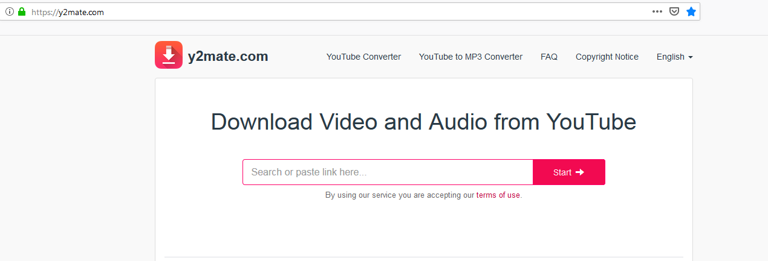
Outline;
This guide has been created to provide instructions on using the site “y2mate.com” to download YouTube videos as either video with audio or just audio. It is important to view the company’s ‘Copyright Notice’ before you use the service.
It can be viewed here: https://y2mate.com/terms-of-service
HobStar assumes that before continuing with this document that have read and understood the copyright information found on the “y2mate” site.

Document Name: “Downloading YouTube Videos.docx ”
Document Details: Version 0.2 (Q4, 2024)
Document Status: in use

Author: Paul H - hobstar@pm.me
Editor: N/A

Legal Information:
This document has been created in accordance and compliance with all of HobStar Computer Services’ (to be further referred to as ‘HobStar’) legal obligations. All information is intended as training material and does not necessarily reflect HobStar’s views.

Updates to this document:
This document still requires authorization and checking to be performed and completed in order for it to be considered a legitimate HobStar document. Any version of this document that is listed as a ‘Draft’ is not a finished product and might not reflect the intended finished product.

Usage of this document:
This document is intended to be presented to students for their use. Any unintended results of using this document can not be held against HobStar

Notable Version Updates
Version 0.1 - Document Created
Version 0.2 - Small updates to format and site to be used

Table of Contents

Table of Contents 3
Preamble; 4
Steps; 5
Step 1; Choose a video 5
Step 2; Copy the link 5
Step 3; Go to y2mate 6
Step 4; Paste link 6
Step 5; Select quality 7
Step 6; Download 8
Step 7; For audio 9
Step 8; Paste link 9
Step 9; Select quality 10
Step 10; Download 11
Closing thoughts; 12

Preamble;
YouTube is a fantastic server, you can view videos on an almost infinite number of topics. But what do you do if you want to have access to a video when you know you are going to be off line? Or you would like to listen to a long meditation session but not have to be tethered to your computer?

There are many services and programs out there that allow you to capture and download videos and audio from YouTube. This guide has been created to use one such service called “y2mate” which allows you to download video or audio versions of YouTube videos.

It is important to read the ‘Copyright Notice’ on the site and only use this service under the ‘fair use’ clause, which states that it is for personal use only and that you do not claim the content as your own or to try and profit from it.

That being said, let us jump into fining out how to do this.

Note;
I am using Firefox as my browser, but you can also use one that you prefer to use.

Step 1; Choose a video
Go to YouTube and find the video you want to download. For this example I am going to download one of my own videos. Source: https://www.youtube.com/watch?v=Xon6OxesuUI
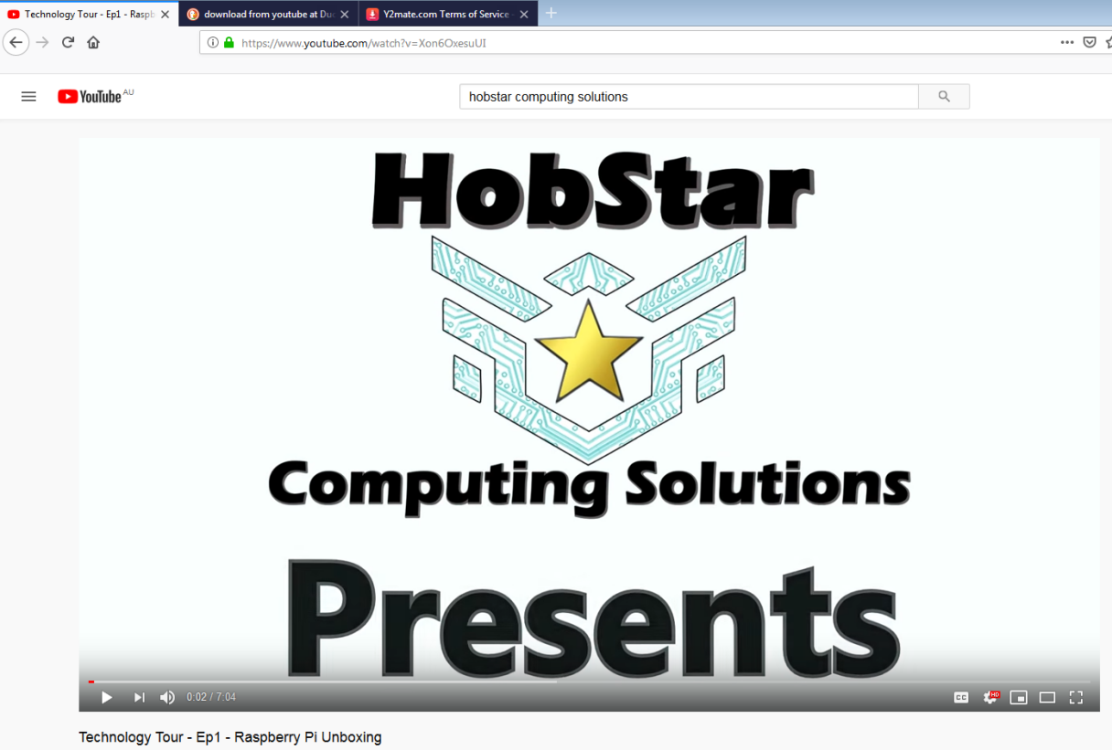

Step 2; Copy the link
Copy the URL from the address bar. To do so, click in the address bar, highlight and press the keyboard short cut [Ctrl] + [C]
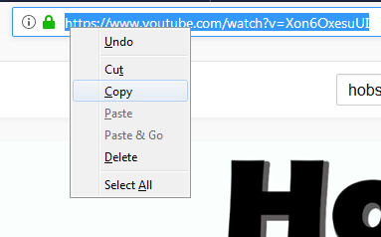
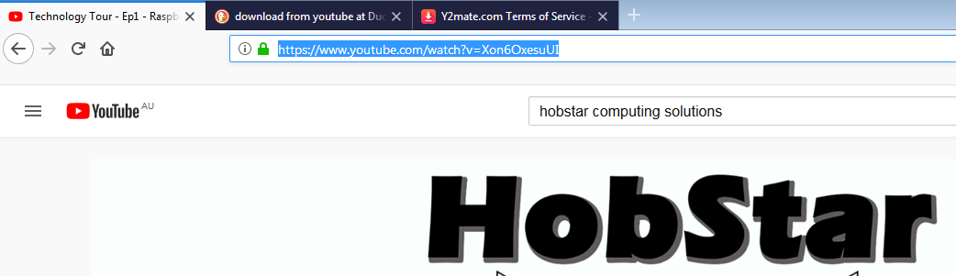
Alternately you can copy by (Right Mouse Clicking) on the highlighted text and select ‘Copy’ from the dropdown.

Step 3; Go to y2mate
Navigate to the “y2mate” site. I usually just Search for “Download from YouTube” and look for the URL “https://y2mate.com” but you can go any way you like. Click on the link or type the exact URL into your address bar and press the [Enter] key. NB: as this iste is not ‘secure’ you should not entere in any personal information. As we are only pasting a link, it is fine to use.
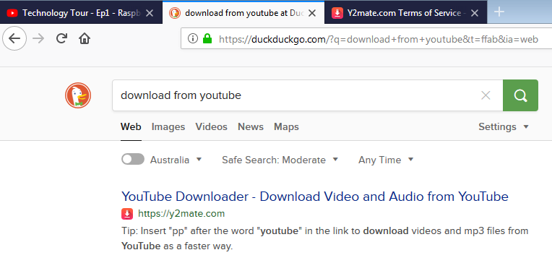

Step 4; Paste link
IF you want to download the audio only, please skip to “Step 7”
Paste the link we copied back in step 2 into the box that says “Search or paste link here”

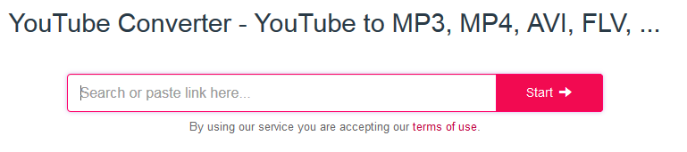
If it does not automatically bring up your intended video, click the [Start] button.

Step 5; Select quality
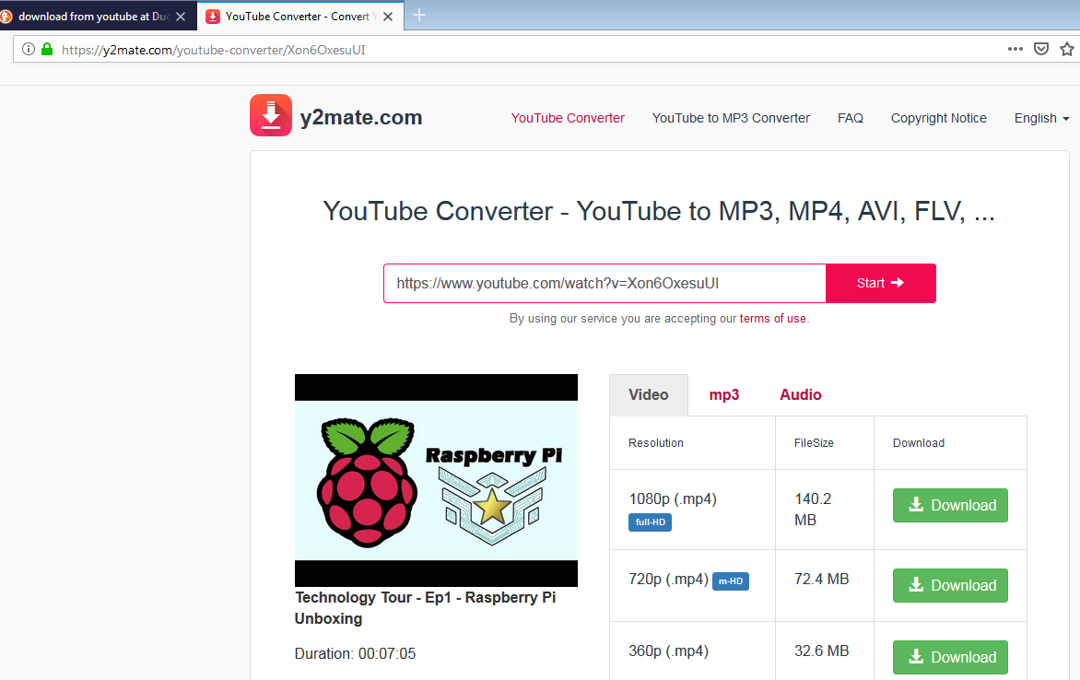
Choose the quality your require for the video play back by clicking the corresponding [Download] button
NB:
The higher the ‘Resolution’ the better the quality will be but also the bigger the downloaded file will be.
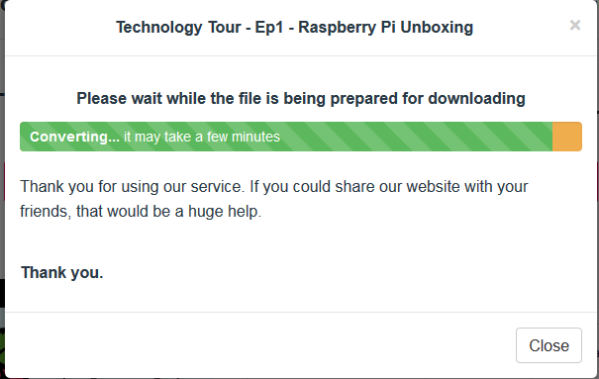
An information box will appear to let you know that it is ‘converting’ (or getting it ready to download)

Step 6; Download
Depending on your browser, you will either be asked where to save your file or it will automatically download to you ‘Download’ Folder
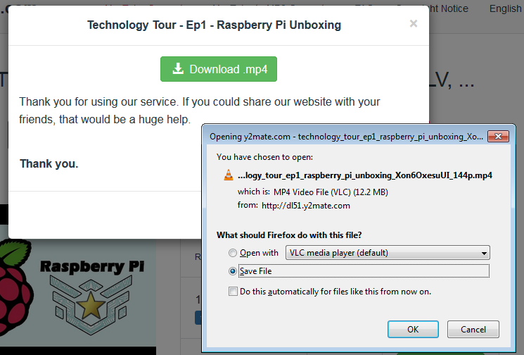
If you are downloading video, you have reached the end of the instructions.
If you are downlighter audio, you should already be at step 7.
Read to the end for final thoughts.

Step 7; For audio
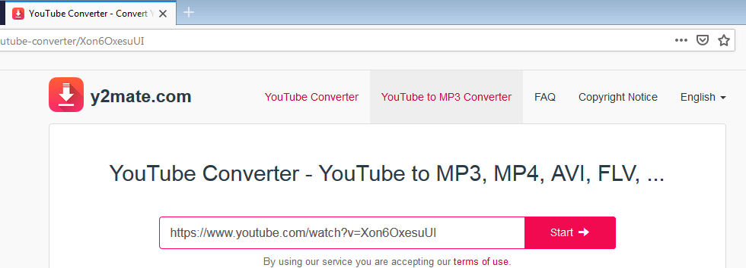
To download audio instead of video, click on the ‘YouTube to MP3 Converter’ tab at the top of the window.

Step 8; Paste link
Paste the link we copied back in step 2 into the box that says “Search or paste link here”
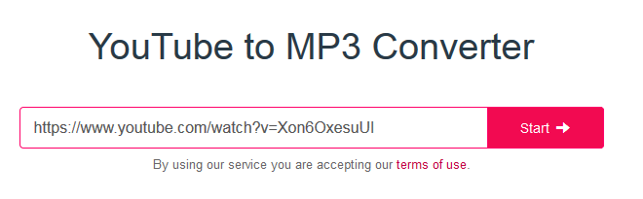
If it does not automatically bring up your intended video, click the [Start] button.

Step 9; Select quality
Click the drop down box and choose the quality of the audio to download. The higher the quality the better it will sound but also the larger the file will be.
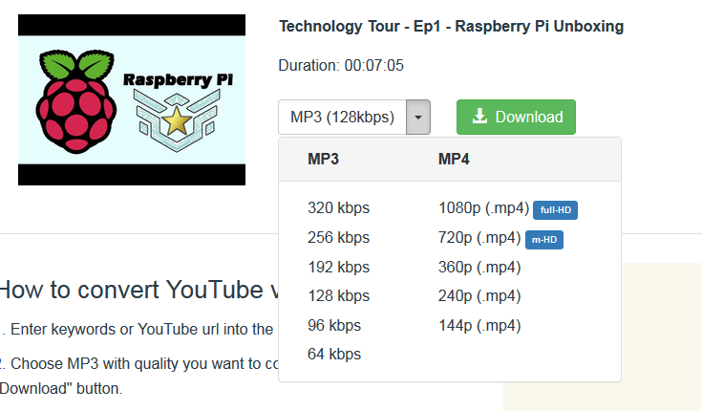
Once chosen, click the [Download] button
An information box will appear to let you know that it is ‘converting’ (or getting it ready to download.)
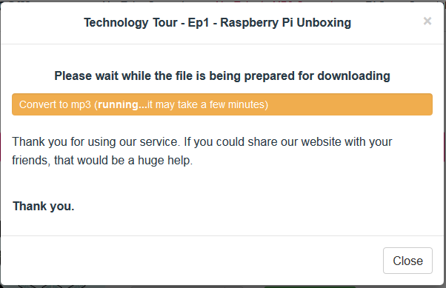

Step 10; Download
Depending on your browser, you will either be asked where to save your file or it will automatically download to you ‘Download’ Folder
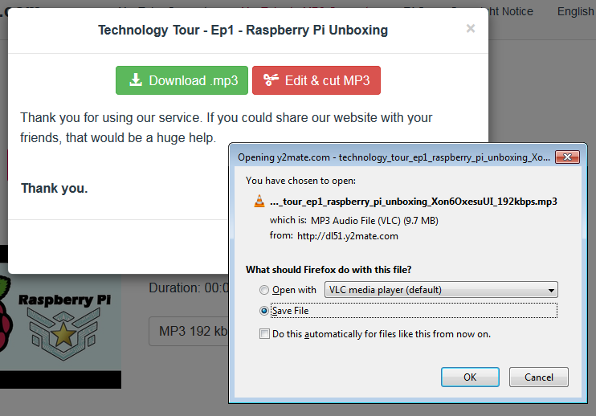
You have reached the end of the instructions.

Closing thoughts;
There are additional methods for downloading videos or audio using this service. Read around on the site for information on how to do so.

Some terminology you might have encountered but not be familiar with;
MP4; a video file open-able by most operating systems
MP3; an audio file that does not contain any video. Open-able by most operating systems

You might see a small orange traffic cone in some of the screen-shots about downloading the files, this an icon for a free program I use for viewing and listening to files, it is called VLC Media Player. If you are interested you can check it out here: https://www.videolan.org/vlc/

If you have any issues following this set of instructions, wish to provide feedback, or for any thing else, please do not hesitate to contact me at; hobstar@protonmail.com

Thanks for reading, and never stop learning.

Warm Regards,
Paul

