Microsoft (MS) Word & File Management

Microsoft Word 2021 is a word-processing application that allows you to create a variety of documents, including letters, resumes, and more. In this lesson, you'll learn how to navigate the Word interface and become familiar with some of its most important features, such as the Ribbon, Quick Access Toolbar, and Backstage view.

Getting Started

- Click the Windows Start Button (Bottom Left Corner of the screen), in Windows 11, it may be closer to the middle bottom of the screen

- Just start typing the name of the program you want to open (“Word”)
- Click on the one you want.

NB: Instead of typing the name, you can also scroll down the list of programs and click on “Word”

The Word Interface
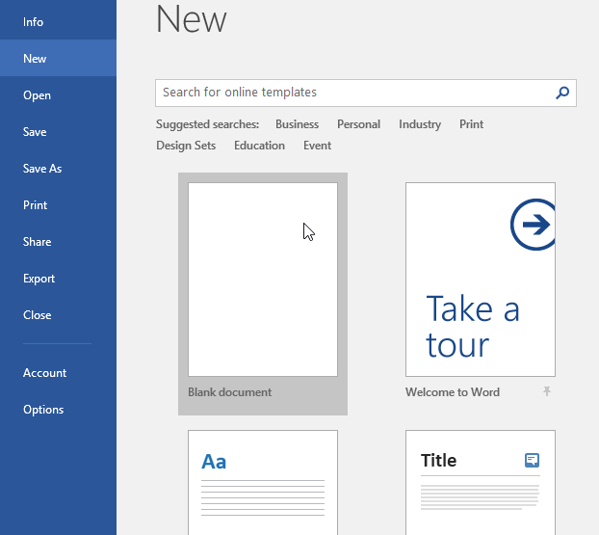
When you open Word for the first time, the ‘Start Screen’ will appear. From here, you'll be able to create a new document, choose a template, and access your recently edited documents. From the Start Screen, locate and select Blank document to access the Word interface.

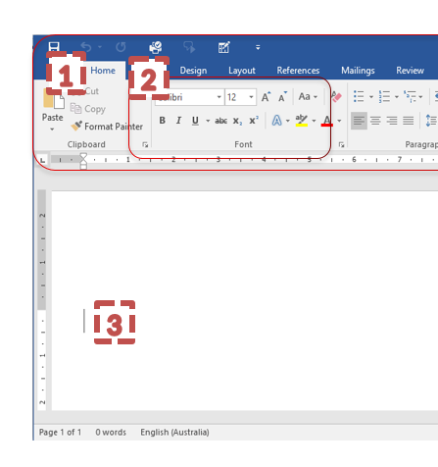
1. The Ribbon
The Ribbon contains all of the commands you will need to perform common tasks in Word. It has multiple tabs, each with several groups of commands (more on this soon).
2. Command Group
Each group contains a series of different commands. Simply click any command to apply it. Some groups also have an arrow in the bottom right corner, which you can click to see even more commands.
3. Document Pane
This is where you’ll type and edit text in the document.
BONUS: Mouse Over & Tell Me More
You can find out a lot of information about a command button by simply moving your mouse cursor over it and NOT clicking it for a moment. A small box will appear with information and sometimes examples of how each button could be used. Some will also have a ‘Tell me more’ option at the bottom that will open the built-in help feature of Word with an article on how to get the most out of the desired button.

Entering text into Word
Before we look at anything else, we are going to enter some text into Word so we can then learn how to manipulate it. My favourite sentence to type is (once again); “The quick brown fox jumps over the lazy dog.”
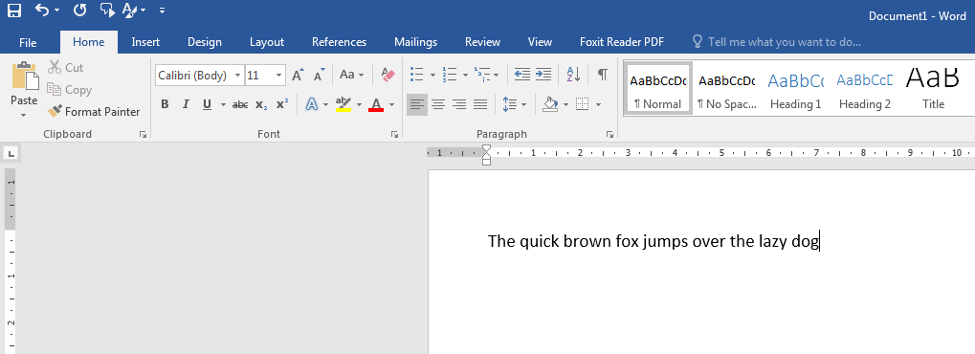

Type this into Word now, then press the [Enter] key and type it again. Do this a few more times.
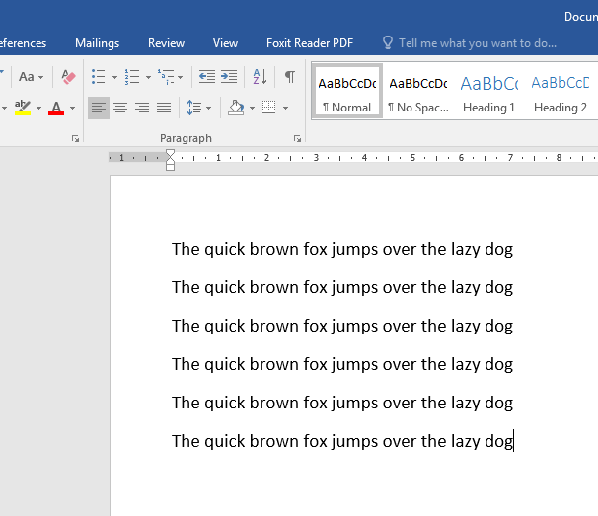

Using the tools
Now that we have some text entered, let’s see what we can do with it. To be able to change the way our text looks, the simplest way is to a) first highlight the text you want to change, then b) click a button on the Ribbon to make a change
Here’s how to highlight one line;
- Clicking and holding the Left Mouse Button at either the start or end of the line you want to select.
- Move the mouse to the opposite side.
- Release the Left Mouse Click.
NB: If your selection is going a bit ‘everywhere’ don’t let go of the Left Mouse Click, just pull it back into line. If you must reset your selection, click once outside of your selection, and try again.
Together in class: let’s have a look
Looking at the “Font” Command Group make each line different by selecting it and changing the; font type, font size, colour, underline, etc.
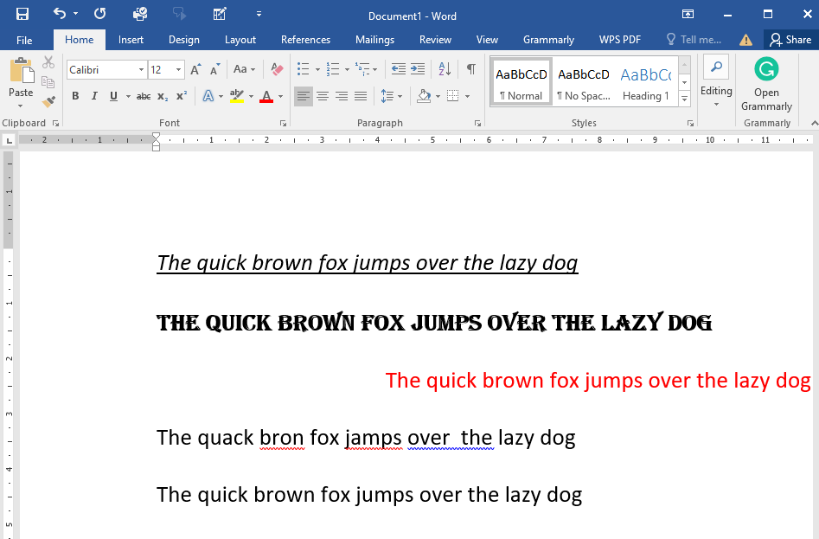
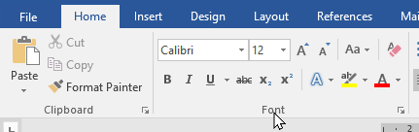
Pro Tip: Another useful one is in the next Command Group (Paragraph), we can change the alignment of text on a per-line basis. I used the [Center] option to make one of my lines align to the centre of the page.
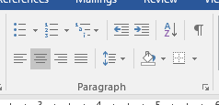
NB: Words underlined in red signify a misspelt word, or at least it’s not in the in-built dictionary. Blue indicated a punctuation/ grammar issue, usually a double space.

You can Right Mouse Click on an underlined word to get correction options.

How Undo and Re-Do work (advanced)
When you open a new document (any MS Office program) and start working, it keeps a history of all of your actions. These actions are stored in the computer’s memory and can be stepped through going forward or backwards in time. There are two main ways to achieve this and there are a few important things to remember when using Undo and Re-Do, let’s start with how we do it;
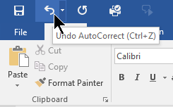

Option A) Press the Undo or Re-do button found in the top left of all MS Office programs

Option B) Use the keyboard short-cuts as displayed when mousing over the Undo or Re-do button. The short-cuts are;
Undo; [Ctrl] + [Z]
Re-Do; [Ctrl] + [Y]
Every time you press the letter [Z] or [Y] whilst still holding the [Ctrl] key, you will move one step either backwards or forwards in your history of actions.
Special Notes:
There is a limit to how many steps it can take.
If you save your work, close it and open it again, the list of historical steps will be cleared off, meaning you can’t undo steps.
If you have not used Undo, you cannot Re-Do anything.

Backstage view
Backstage view gives you various options for saving, opening a file, printing, and sharing your document. To access Backstage view, click the File tab on the Ribbon. NB: We will be leaning how to save and retrieve files next week, bring your USB drives. :)
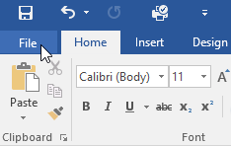

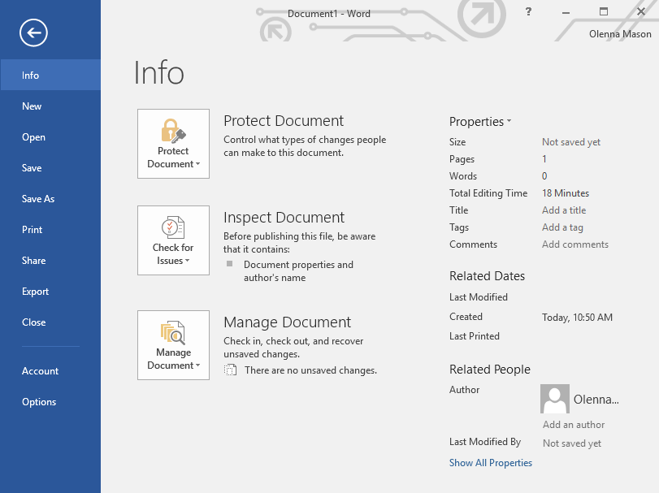
Bonus: Changing your Office theme to ‘Dark Gray’
If you wish to do this, then from any Microsoft Office program;
- Click the [File] tab in the top left of the ribbon. This section is called the ‘Backstage View’
- Click the [Options] button at the bottom of the Backstage View section. NB: If you don’t see it, you might need to click “More” first
- You will start in the [General] tab, here we will find the option for ‘Office Theme.’ Click the drop-down arrow next to this, select ‘Dark Gray’ and then press the [OK] button
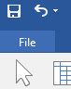
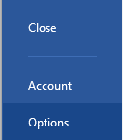
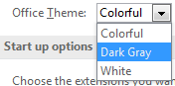
Press the [<=] back arrow (or the [Esc] key on your keyboard) to exit the Backstage View
1
2
3

How to Save (to a USB)
When is a good time to save? Once you already have a heap of work entered into your document? Or perhaps it’s best to save your work before you have even typed your first line of text?
Word, and all of the Office products, have fairly robust ‘auto-save’ features that can work even if you have not yet saved a document… most of the time. It is better, therefore, to err on the side of caution and save your work before you begin.
There are two types of save that we need to remember, the first is ‘Save As’ and the other is ‘Save.’ The difference can trip up first-time users but there are very limited consequences in getting it wrong. First, let's define the two.
Save As: Give a document a name and tell it where to be saved. This is used the first time you save a document OR if you want to make a copy of the document with either a different name, different location or both.
A good time to use the “Save As” option is when you want to save a version of a document or make a copy to put onto a USB Drive.
Save: Update changes to an existing document that has already been named. The file stays where it has already been saved when you did your “Save As” and it keeps the same name as well. This option updates an existing file.
So what can go wrong? If you always use “Save As” and change the directory or file name, you might end up with many versions of the same file but in different locations and stages of progress. This can make it very hard to work out which is the correct one you are supposed to be working on.

Scenario: You start a new document at home, and type up some stuff for your resume. You Save As “My Resume.docx” on your computer (Probably in your Documents folder) Bonus: “.docx” is the file extension for an MS Word file.
The following day you want to take your resume to work to finish it up (make sure the boss doesn’t see it), so you copy the file onto a USB drive.
At work, you finish up your resume and take it home on your USB drive.
At home, you now have two copies, one on the home computer (the old one) and one on your USB (the new one).
Q: What do you do?
How to ‘Save As’ (Detailed Steps)
NB: The file name listed at the top of the screen before you save will be ‘Document 1’ or something similar
- Select [File] from the Ribbon
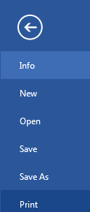
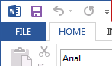

- Select [Save As] option

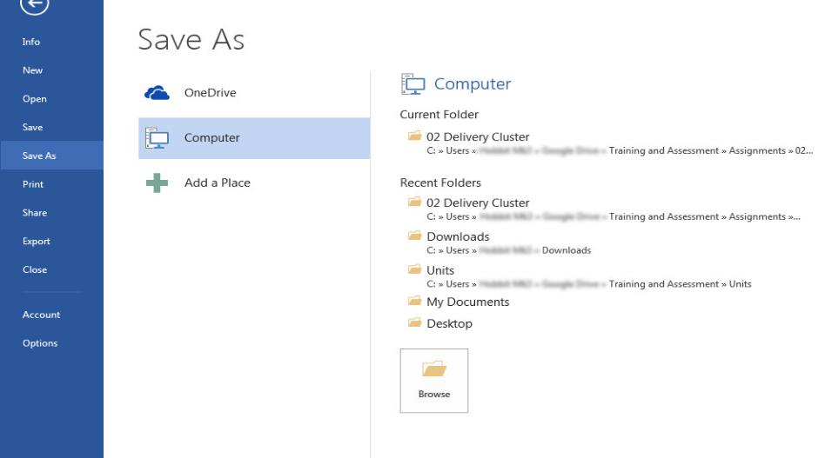
3. Select [Browse]

Sometimes here

4. Here you can choose the location(1) and the file name(2) and then click [Save](3)
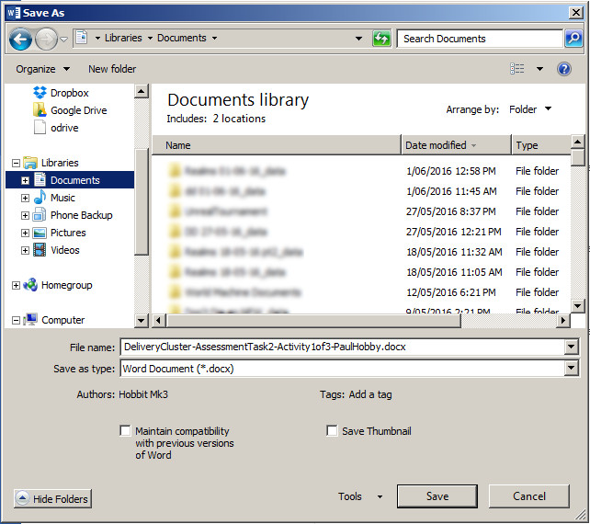
NB: You will only see files in the location if they are of the same type. Try not to worry if you can’t see files saved in other programs, you won’t see them when saving.
2
1
3
NB2: You should now see your file name at the top of the window.

Save As - Quick Steps
- Click [File]
- Click [Save As]
- Click [Browse]
- Locate where you want to save. Options;
  - This Computer -> Local Disk (D:) -> DISK_TOSHIBA -> {Folder Name}
  - Documents
  - Somewhere else
- Click in the box next to ‘File Name’ and give your file a name that will help you to find it again, e.g. Recipes, Letter to Mum, My Story
- Click the [Save] button, you will now see the name of the file appear at the top of the window once it has finished saving.

How to Eject Your USB Drive
People often ask me “Is it OK to just pull my USB drive out?” and I usually reply with “Doing so is like not stopping your car before you get out.”
To prevent data corruption and faulty USB drives, it’s best to ‘stop’ or ‘eject’ it before removing it from the computer. But even before that, it’s important to first make sure you’ve closed any programs that might be using the USB. This means saving your work and closing off the programs.
So here are the steps to eject your USB;
- Save your work and close any programs that might be using any files on your USB drive
- We are looking for the ‘Remove USB’ icon which looks like this [](a) if you can’t see it, click the arrow [] (b) down the bottom right of your screen (near the clock)
b
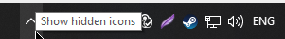
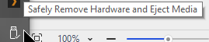
- Select ‘Eject…” on the appropriate USB drive (renaming your drives makes this easier to identify)

a
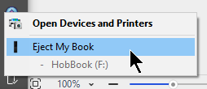
Pro Tip: If it won’t eject, saving ALL of your work and telling the computer to ‘Shut Down’ will force the safe ejection of USBs. Once it’s fully powered down, remove them. This method is a bother if you want to keep using your PC.

Retrieving Your Files
Now that we have some/ a file saved, how do we get it back again? This is the old question of computing;
“Where the heck did I save that file?” ~ everyone who’s used a computer.
Here were are going to look at two different options.

Option A
If you know which program you created your file in, you can open that program first and then open the file you want. NB: You will not see files created in other programs.
- Open your program, e.g. Word, Excel, PowerPoint or Publisher
- Click [File] (if your program is already open)
- Click [Open]
- Click [Browse]
- Navigate to where you save your file, e.g.
  - This Computer -> USB Disk (D:) -> {Folder Name}
  - Documents
  - Somewhere else
- Click on the file you want to open, click [Open]
- Alternatively; Double Left-click on the file you want to open

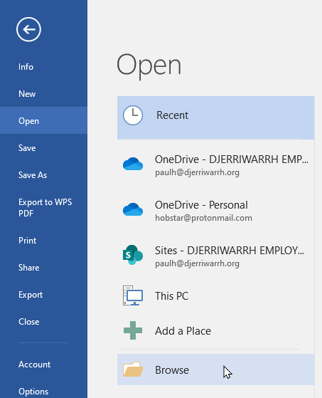
Pro Tip: If you don’t Double Left-click fast enough (technically two single clicks) you will move to edit the file’s name. If you do not want to rename the file you can either click somewhere else on the screen or press the [Esc] (Escape) key on the keyboard

Option B

If you are not sure which program you made your file in, or you simply wish to view the files saved on your computer, follow the steps below.
- Click the icon for Windows Explorer on your Taskbar
- Use the Navigation Panel on the left-hand side of Windows Explorer to locate where your files have been saved, e.g
  - This Computer -> USB Disk (D:) -> {Folder Name}
  - Documents
  - Somewhere else
- Double-left-click on the file you want to open
- Alternatively, Single Left-click on the file you want to open, press the [Enter] key on your keyboard
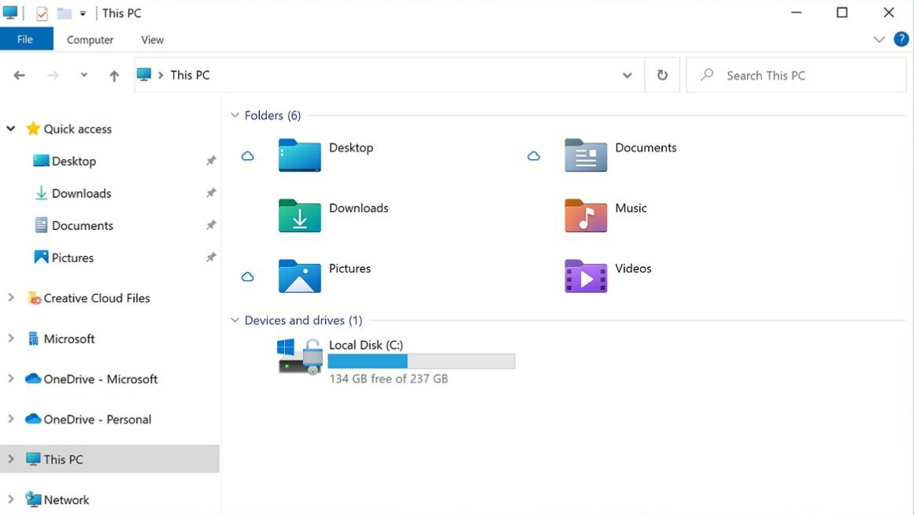

File Systems

File Systems are the way that you organise and order your folders and files within your computer. Through this section we will liken the file system on your computer to a physical filing system that you might be familiar with; the humble filing cabinet. The concept of storing files in your computer, and using a filing cabinet is very similar, with the core concept being; logical sequencing and grouping of information. What we want to achieve is twofold.
- To be able to retrieve any given piece of information or file
- To have a place to save new files as we make them.
If we continue the filing cabinet analogy and imagine taking a stack of papers that we want to store in there, how useful would it be to simply dump all of the files in the first draw? It sure would be easier, that’s for sure, but good luck finding that one important file that went in there with the rest. To make a filing cabinet efficient we add folders to group information, use dividers for more board groups and even might consider using colour codes as well.
This same principle can be used to create a structure on your computer that will give you an ordered place to save your files and allow you to find them again.
On the following page, we use the filing cabinet example and apply computer terms to each part. The idea is that due to their similarities, we can further the example and help gain an understanding of this rather complex topic in a way that makes it easier to understand.
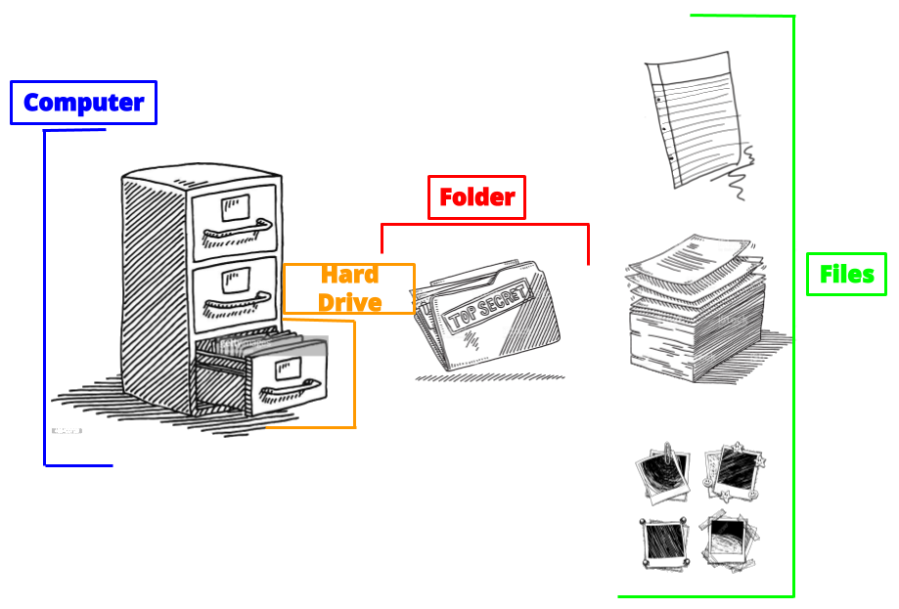
1
2
3
4
Computer
Hard Drive
Folder
Files

Above we can see the four parts that we will focus on;
- The whole filing cabinet is like our computer
- Each draw in the cabinet is like a hard drive
- Within the draw we can have folders, this is the same on a computer
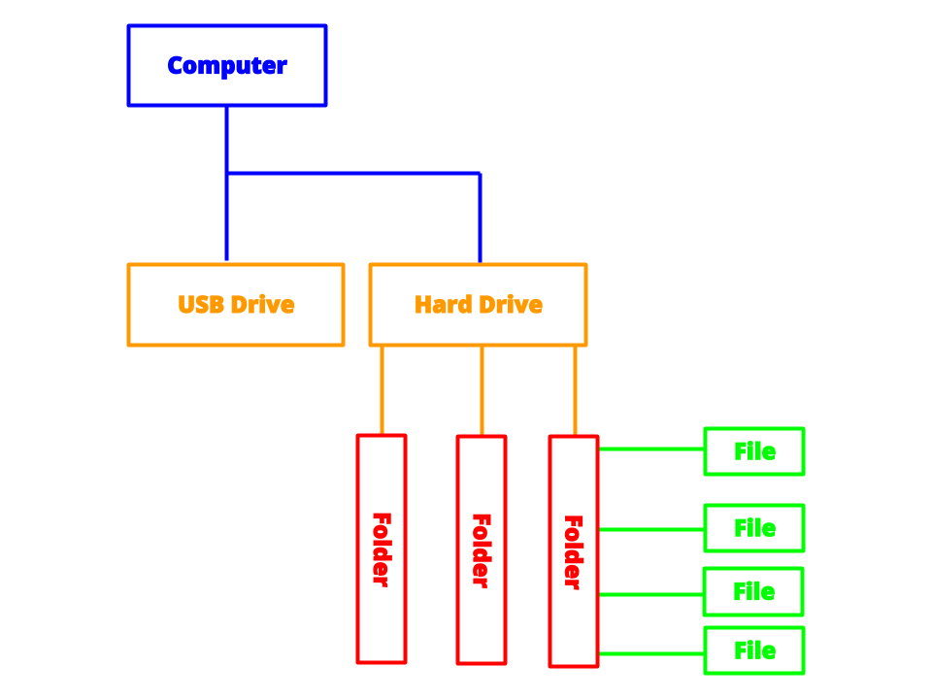
- Finally, each folder can contain files, also just like a computer
Here we can see the same example that we just looked at, however, this time without the pictures.
Files
Folder

4
1
Files
Files
Files

Folder
Folder
3
2

Folders can also contain OTHER folders as well as files. Do not let this concept hurt your brain too much, simply think of it as subcategories within categories. For example, a folder called ‘Dogs’ might have three folders inside of it called; ‘Big Dogs’, ‘Medium Dogs’, and ‘Small Dogs.’ But don’t forget that the main folder (Dogs) could also still contain files as well.
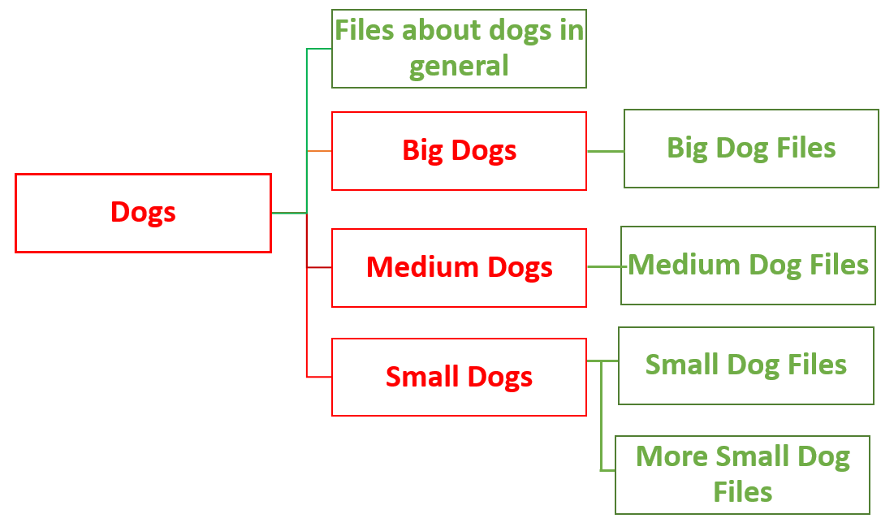
Folder
Folder
Folder
Folder
Files
Files
Files
Files
Files

The example on the next page shows a possible file structure for a home computer. Microsoft Windows comes pre-setup with five usefully named folders, designed to guide users in separating their files. These folders are; Documents, Music, Pictures, Videos and Downloads.
As a user, you can create additional ‘subfolders’ within these existing folders. Doing so will create these logical paths to places where you will be able to easily and logically follow to store, and, retrieve your files.

Below we can see that within the ‘Documents’ folder there are five sub-folders. Within the sub-folder ‘Personal’ we have four more sub-folders. Within the ‘Centrelink Stuff’ folder there are yet more sub-folders, one of which is ‘Requests.’ Finally, within this folder, we find our saved MS Word files that are requests made to Centrelink.
This might seem to be a roundabout way to save your files, and to some, this is true. For day-to-day computer use you don’t have to create as many levels of folders and sub-folders to store your files, probably.
This is where it comes down to the individual user and their preferences and requirements.
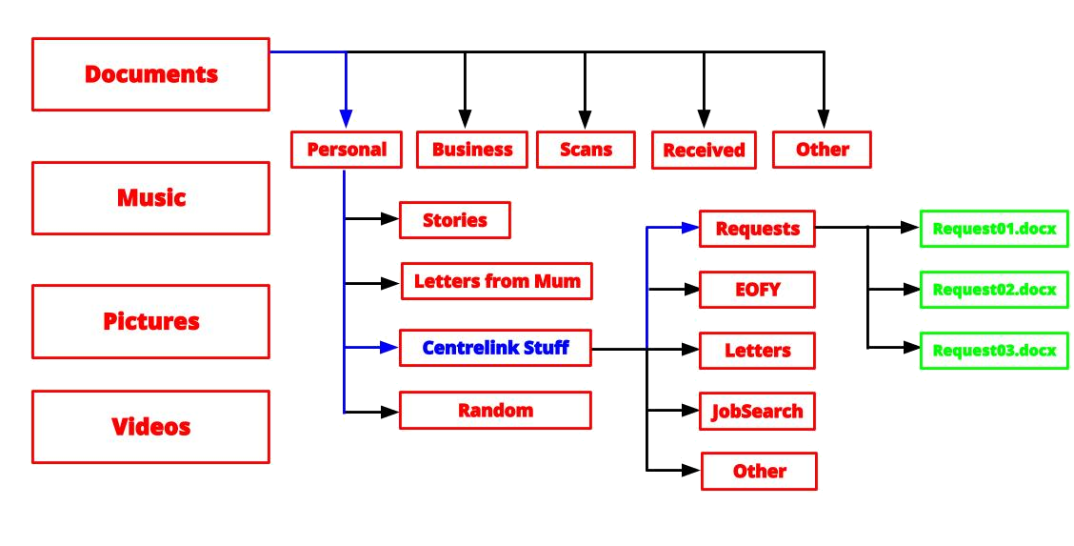

Folders

Files

Activity - Create a Folder Structure
Resources:
Computer, a USB Disk, pen and paper
Task:
Make a Folder/File Structure on your USB drive for your “Intermediate Computer” work

File System Creation – Planning:
Consider the hierarchy you want your file system to follow. Think of a business structure
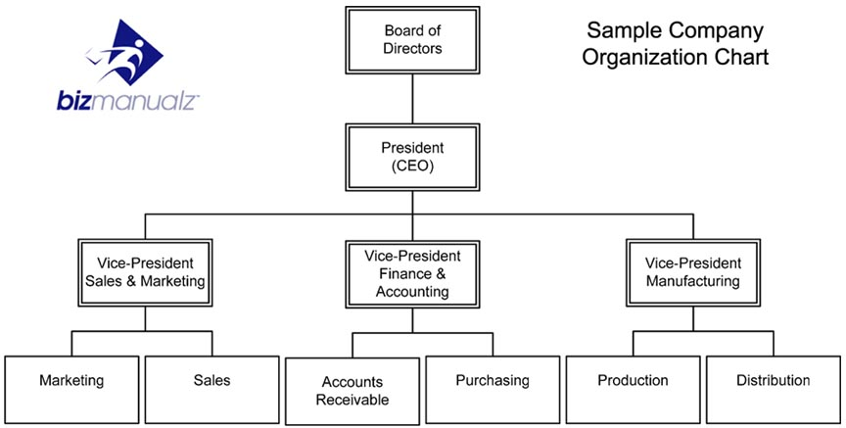
Let us now use this model to plan how we will create the file system on our USB Flash Drive

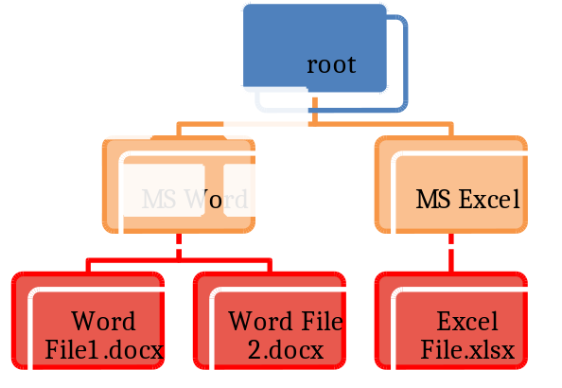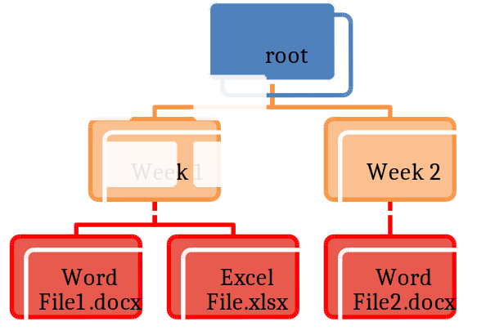
NB: ‘root’ refers to the highest level of file storage and represents the media itself. E.g. when you insert a USB drive with nothing on it and start adding things, you start at the root of that device.

File System Creation - Instructions

Now that we have our plan let us make our file system
- Click the ‘File Explorer icon on the Taskbar
- Navigate to your USB Flash drive (This PC -> “Local Disk D:…” -> Disk Toshiba) NB: the drive letter and name will depend on the USB brand and what other drive letters are already used
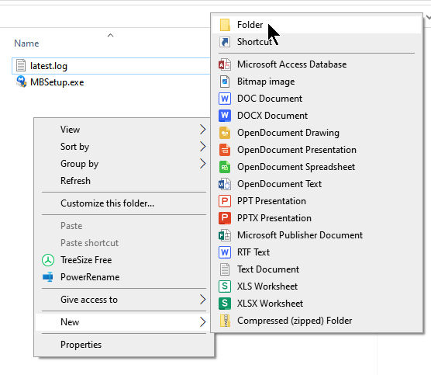
- Right Mouse Click on a blank area, mouse over ‘New’ and Left Mouse Click on ‘Create new folder’

Type in the name you wish to assign to this folder and press the [Enter] key on the keyboard
- We can now Double Left Mouse Click on our new folder to open it
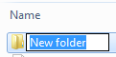
- Here we can repeat the steps on the previous slide to create more folders if we wish

Moving around File System
Now that we have our new file system started, it is a good idea to learn how to get around. As always there are many ways to do the same thing.
The easiest way is to use the ‘Address Bar’ at the top of the screen. Here we can see the ‘path’ we have travelled to get to our current folder. Click on another part of the path to go there now.

NB: Your screen will look different to mine because I am using Windows 10 and my file system has been created to meet my needs.
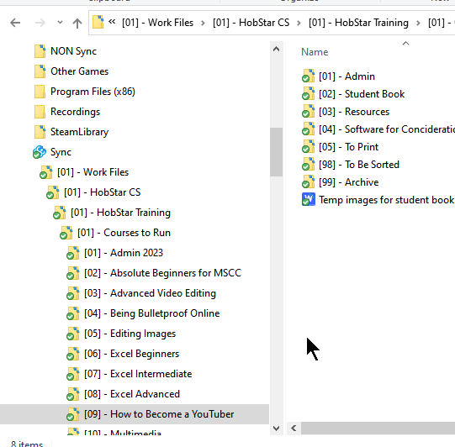
Alternatively, you can use the navigation panel on the left-hand side to move around. This panel shows a more hierarchical view of your folders and is useful for quick access to the folders that Microsoft Windows sets up by default (Documents, Pictures, Videos, etc)

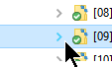
These folders will need to be expanded to view the contents, ones with arrows next to them indicate that sub-folders are present

Advanced: The arrows in the Top Left of the File Explorer window can also be used to move between folders, however, they might not work the way you would expect them to. If you have visited a location that is not part of your current ‘path’ the forward and backward buttons will take you between the two locations. For example, if you were in your ‘MS Word’ folder and then entered the ‘Pictures’ folder, the back button would take you back to the ‘MS Word’ folder
Question: What does the small arrow to the right of the ‘forward’ button do when clicked?
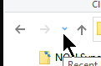

Activity - Create a File, Save it and Retrieve it
Resources:
Computer, a USB Disk, MS Word or Wordpad
Task:
Create a new file in MS Word or Wordpad, type some information. Save your file into one of your newly created folders. Close the file and then retrieve it.

Chapter 2 Review
A chapter full of useful things for creating, saving and retrieving work. Here are the highlights;
How to Open a Program;
- Click the Windows Start Button (Bottom Left Corner of the screen), in Windows 11, it may be closer to the middle bottom of the screen
- Just start typing the name of the program you want to open (“Word”)
- Click on the one you want.
How to Highlight one Line;
- Clicking and holding the Left Mouse Button at either the start or end of the line you want to select.
- Move the mouse to the opposite side.
- Release the Left Mouse Click.

Useful Shortcuts; (Pro Tip: Remember to hold [Ctrl] and tap the letter)
Undo; [Ctrl] + [Z]
Re-Do; [Ctrl] + [Y]

Save As - Quick Steps
- Click [File]
- Click [Save As]
- Click [Browse]
- Locate where you want to save. Options;
  - This Computer -> Local Disk (D:) -> DISK_TOSHIBA -> {Folder Name}
  - Documents
  - Somewhere else
- Click in the box next to ‘File Name’ and give your file a name that will help you to find it again, e.g. Recipes, Letter to Mum, My Story
- Click the [Save] button, you will now see the name of the file appear at the top of the window once it has finished saving.

