
Gmail on Desktop/Browser
- Log in to your Gmail account.
- In the upper-left corner of the window, click the button to create a new e-mail message. You may also reply to a message you have received previously.
- When you're ready to insert an attachment into the body of your message, click the icon at the bottom of the message window.
- Navigate to the location of the file(s) you want to attach, make your selections (A), and then click Open (B).
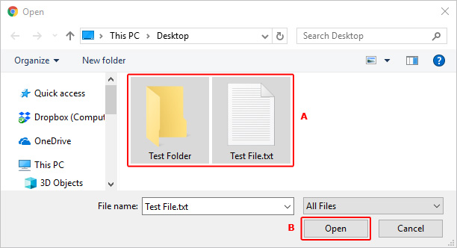
- When you've successfully attached your items, you see them at the bottom of the body of your message.
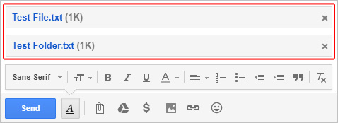
- When you've finished composing your message, click the button.

Gmail on Mobile

- Open Gmail. Tap the Gmail app icon, which resembles a red "M" on a white background. This will open your Gmail inbox if you're logged in.
If you aren't logged in, select your account and/or enter your email address and password to log in.
- Tap the "Compose" icon. It's in the bottom-right corner of the screen. Doing so brings up a new message window.
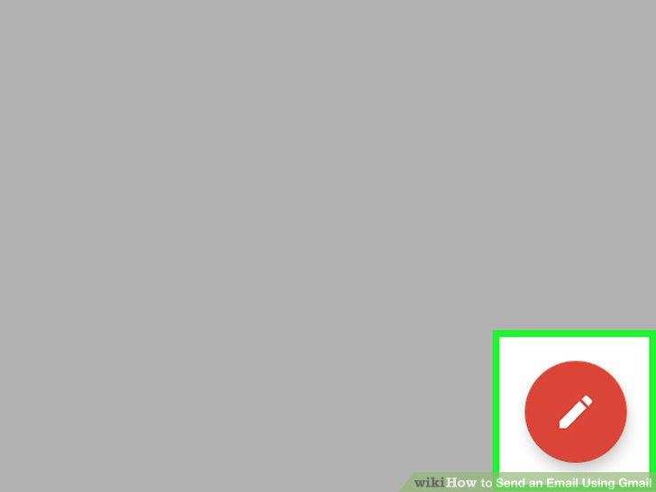

- Enter an email address. Tap the "To" text box, then type in the email address of the person to whom you want to send an email.

- Enter a subject. Tap the "Subject" text box, then enter the subject you want to use.

- Enter your email's message. Tap the "Compose email" text box, then type in whatever you want to use for your email.

- Add files or photos if necessary. If you want to place a file or photo in your email, do the following:
Tap at the top of the screen. Tap Camera roll (iPhone) or Attach file (Android). Select the photo or file you want to use.

- Tap the "Send" icon. It's a paper plane-shaped icon in the top-right corner of the screen. Your email will be sent.

