Mail Merge with MS Word
Document Name: “Mail Merge MS Word - V0.2b.docx ”
Document Details: Version 0.2b (Q2 - 2024) - May
Document Status: draft

Author: Paul Hobby - hobstar@protonmail.com
Editor: N/A

Legal Information:
This document has been created in accordance and compliance with all of HobStar Computer Services’ (to be further referred to as ‘HobStar’) legal obligations. All information is intended as training material and does not necessarily reflect HobStar’s views.

Updates to this document:
This document still requires authorization and checking to be performed and completed in order for it to be considered a legitimate HobStar document. Any version of this document that is listed as a ‘Draft’ is not a finished product and might not reflect the intended finished product.

Usage of this document:
This document is intended to be presented to students for their use. Any unintended results of using this document can not be held against HobStar
Notable Version Updates
Version 0.1 - Document Created 2021
Version 0.2 - Updated for 2023
Version 0.2b – Modified, removed excel from WikiHow and used from Word for Work – T2 -2024

Mail Merge
A powerful tool which allows for making a single document for each entry in a list of customers, staff members or clients. The idea being that you don’t have to make a new document for each person, just one master one with fields that will populate from your list.
Learn how to perform mail merges for creating personalized letters, envelopes, labels, and more from a data source.
Mail Merge is a powerful feature in Microsoft Word that allows you to create customized documents by merging a main document (containing generic content) with a data source (such as an Excel spreadsheet or a list of contacts). Here's how to perform a mail merge in Word:

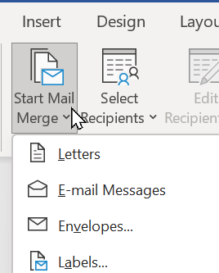
Performing a Mail Merge:
- Open Microsoft Word and create a new document (or use an existing one) that will serve as the main document. In the ‘Mailings’ tab, click the [Start Mail Merge] button and select “Letters”

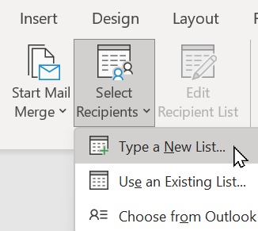
- Click [Select Recipients] and choose “Type a New List…” if you don’t have data from an external source e.g. Excel (more on that later) you can choose from various options to select your data source, such as an Excel spreadsheet, an Access database, an Outlook Contacts list, or simply typing a new list

- We are going to make some changes to the fields available to us.
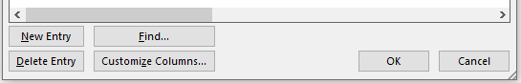
  - Click the [Customize Columns] button

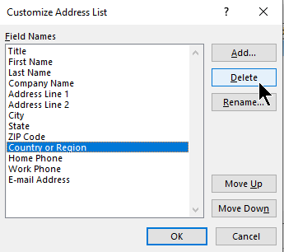
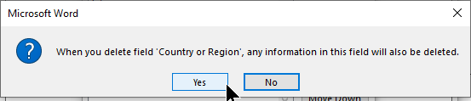
  - Let’s delete the “Country or Region’ by selecting it and clicking the [Delete] button. When prompted, click [Yes] to confirm the deletion.
NB: This will also delete any information that may have been entered in that field if entered
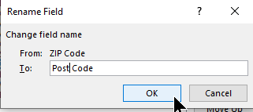
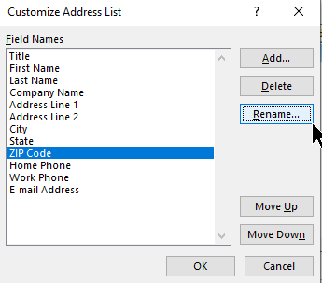
  - Let’s rename ‘ZIP Code’ to ‘Post Code’ by clicking on ‘ZIP Code’ and clicking the [Rename] button. Type the new label and click the [OK] button
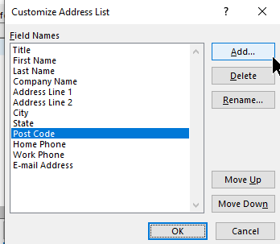
  - Next, click the [Add…] button and when prompted, type “Bonus Points” and click [OK]
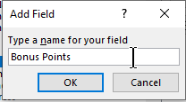
  - Finally, with ‘Bonus Point’ selected, if not already at the bottom of the list, click the [Move Down] button until it is

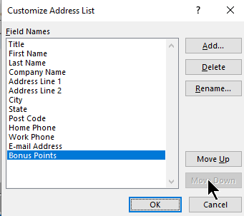

- Now it’s time to enter our customer details. You can make them up or use the info provided on the next page.
TIP: Pressing [Tab] after typing each entry will move you to the next field. E.g, if you are in ‘Title’ and you type “Mrs” and then press [Tab] you will be in the ‘First Name’ field
Pro Tip: Caution is needed when working in this window. It is easy to exit it accidently and lose your work. Ensure you don’t click the [X] button, and when you are finished you click [OK] and then choose where to save the data that has been entered (see step #5)
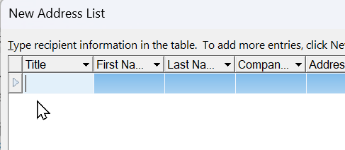
- Click the [OK] button when done and you will be asked to save this list of contact details somewhere. By default, it will go to a ‘My Data’ folder, this is fine for now. Give it a name and click [Save]
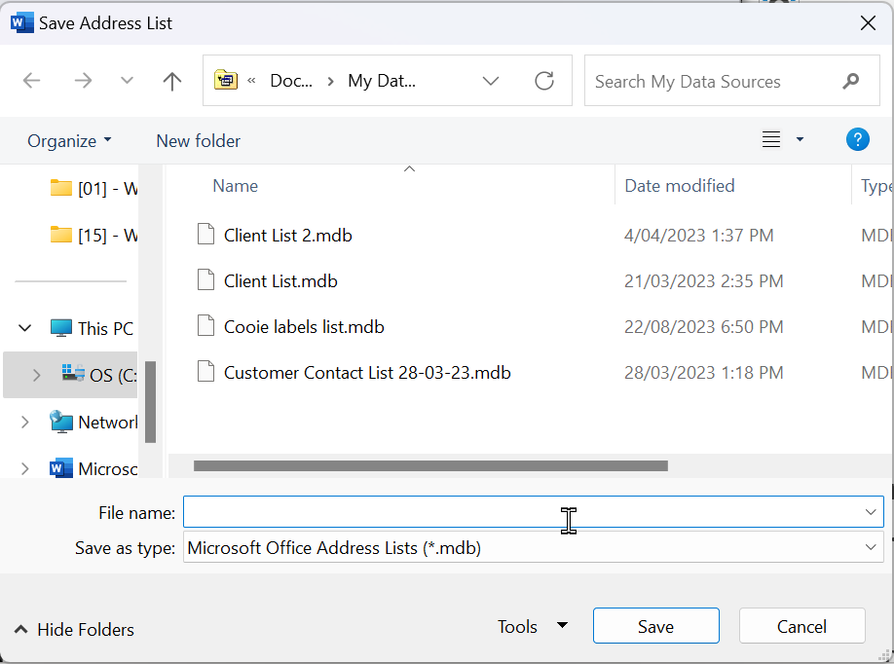
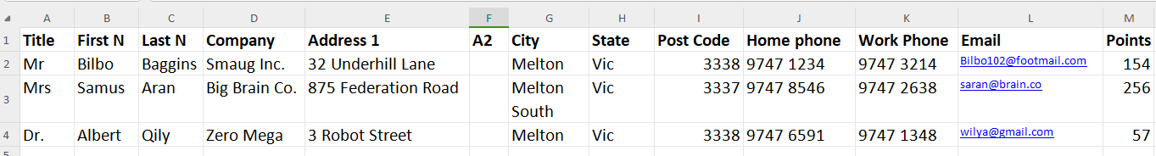
In this document, you can include static content that remains the same for each merged document, as well as placeholders for dynamic data (e.g., recipient names or addresses.) Let’s type up a bit of a document that will used for the Mail Merge NB: I have included spaces “_” where I want the merge fields to be in the future
_
__
_
Dear _ _ _,
Thank you for being a valuable customer. Congratulation on reaching _ points. We hope to see you in store soon to redeem your points for amazing products

Warm Regards,
<you name>

- Once you have you document typed up, place the cursor where you want to insert a merge field (e.g., recipient name or address)
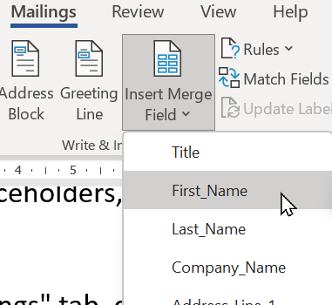
- Go to the "Mailings" tab and click "Insert Merge Field." Choose the field from your data source that corresponds to the data you want to insert
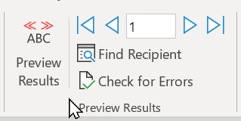
- Click "Preview Results" to see how your main document will look with the actual data from your data source. You can use the arrows in the "Mailings" tab to navigate through the records

- Once you're satisfied with the preview, click "Finish & Merge" in the "Mailings" tab

- Choose the type of merge you want to perform, such as "Print Documents" or "Send Email Messages"
- Follow the prompts to complete the merge. You can either print the merged documents directly or create a new document with the merged content.

Save or Print
You can save the merged documents or print them as needed.

Mail Merge is a versatile tool for creating personalized letters, envelopes, labels, and more. It's commonly used for tasks like sending personalized marketing materials, generating invoices, or creating mass mailings with individualized content. The key to a successful mail merge is having a well-organised data source and a clear understanding of the placeholders you want to insert in your main document.

