Chapter 6 - Microsoft Publisher

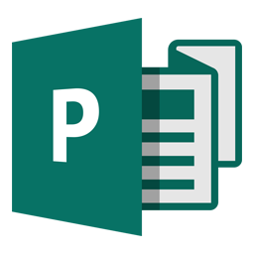

Microsoft Publisher is an entry-level desktop publishing application from Microsoft, differing from Microsoft Word in that the emphasis is placed on page layout and design rather than text composition and proofing

Publisher is included in higher-end editions of Microsoft Office, reflecting Microsoft's emphasis on the application as an easy-to-use and less expensive alternative to the "heavyweights" with a focus on the small business market where firms do not have dedicated design professionals available to make marketing materials and other documents. However, it has a relatively small share of the desktop publishing market, which is dominated by Adobe InDesign and QuarkXPress.

How is it Different to Word?


Used to create:
- Graphically rich print and e-mail newsletters
- Sophisticated tools for creating graphically rich publications
- Greeting cards
- Consistently branded business communications and marketing materials
- Posters or banners
- 3 or 4- panel brochures or flyers
- Many more

Word is better for;
- longer documents
- essays (imagine handing in a theses done in Publisher 3 fold?)
- Some say that word is better for text control

Both have;
- Ribbon
- Spell checker
- Image manipulation (stronger in publisher)
- Templates (very useful in Publisher)


Getting Started
- Click the [Windows Start] button (Bottom left of desktop)
- Find ‘Publisher’ in the list of installed programs and click it

- Search for either “Trifold” or “Brochure”
- Find and select “Business Tri-Fold Brochure (soft blue design)
Note: we can change the colour scheme later.
Additional templates are available for purchase from online companies, e.g. “LayoutReady.com”
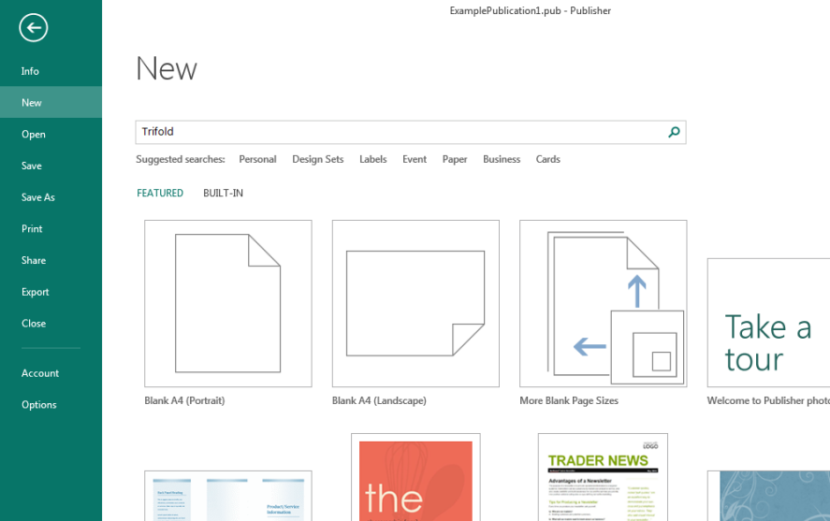
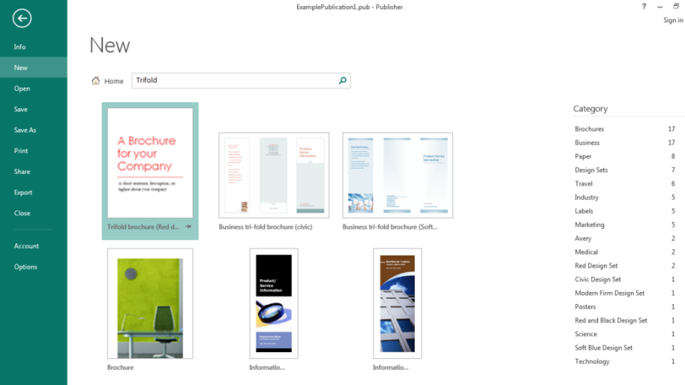
The Interface
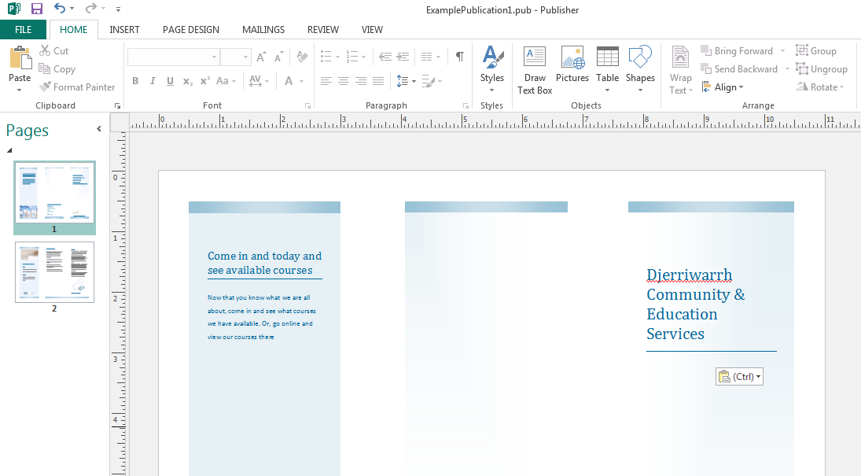
Ribbon
Page Design tab
Work area
Page list

Page Design
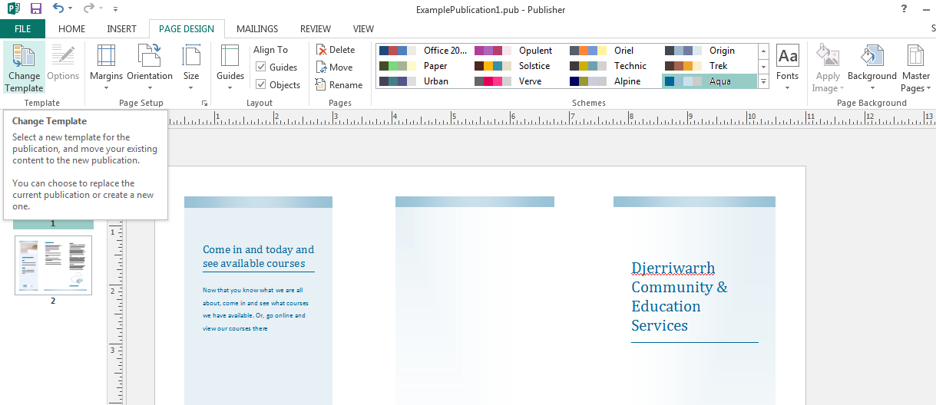
Active tab
Colour Schemes

Inserting Images
Click the [Insert] tab and click the [Online Pictures] button found in the ‘Illustrations’ group.
Type in your search term and press the [Enter] key.
Finally, select the image you wish to use by clicking on it and press the [Insert] button.
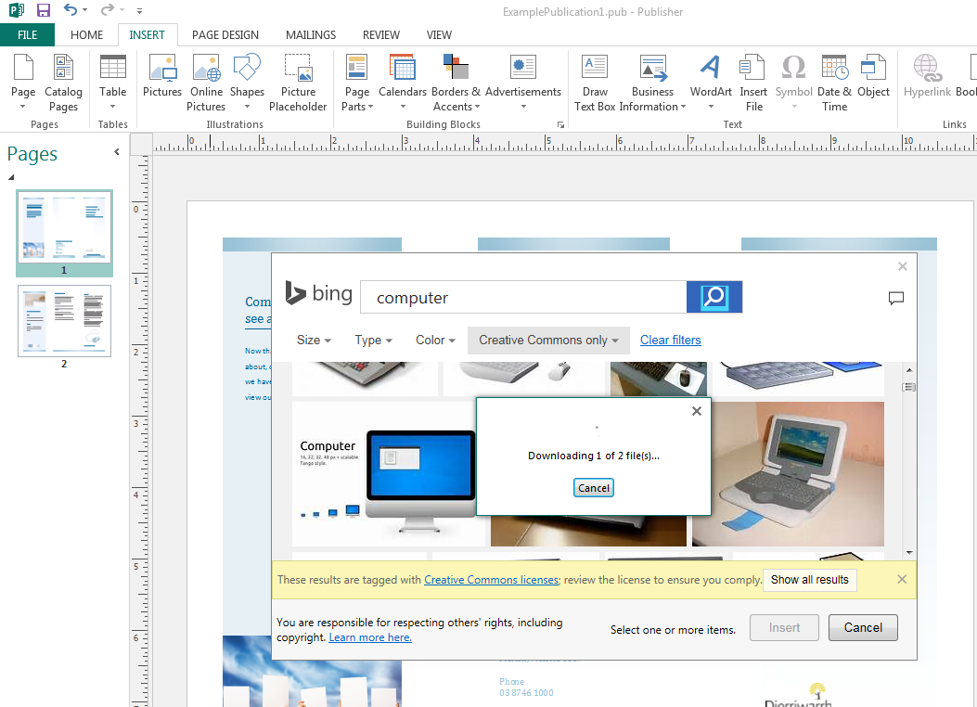

Activity - Tri-Fold Brochure
<See also Chapter 4 - More PowerPoint - Working With Images (page #62 or #75)>
Resources:
Computer, MS Publisher

Task:
You have been asked to create a TriFold Brochure in Publisher. The topic is ‘Occupational health and Safety’

Note:
Look at the existing printout to work out ‘what goes where’

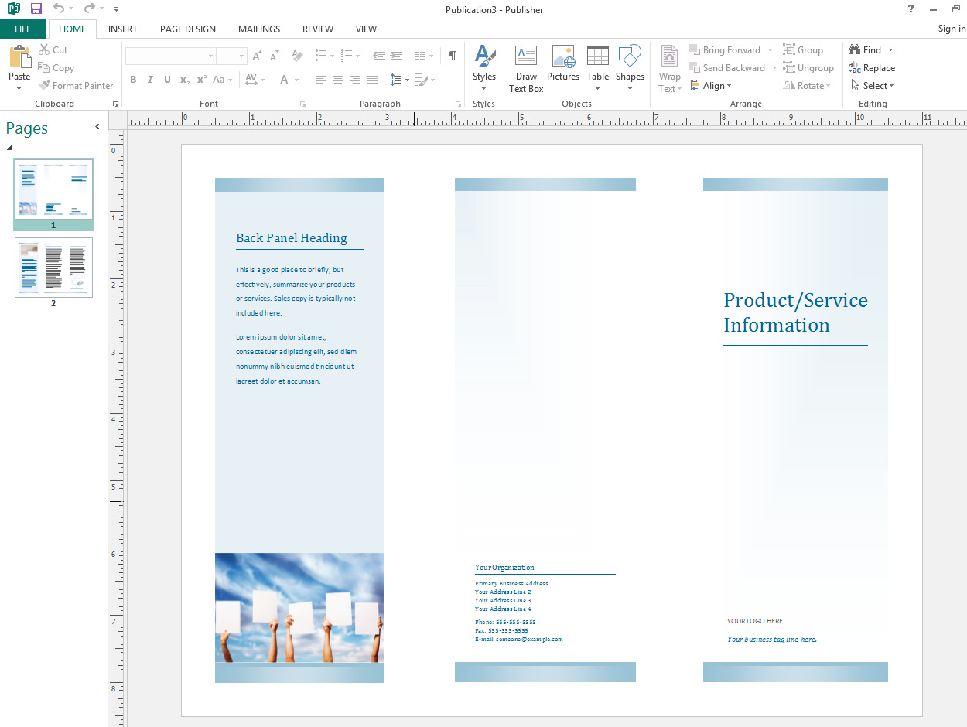

Printing special publications (tri-fold)
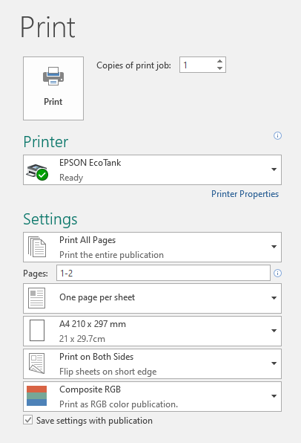
When it comes time to print, there are a few things to check. As this is a booklet, let’s make sure that our booklets look good. Let’s go through each option here and have a look;
- “Printing All Pages” should be already set to “Print the entire publication”
- “Pages” can be left on “1-2”
- “One page per sheet” is selected
- “A4”page size (unless you are doing something fancy)
- “Print on Both Sides” is selected with the “Flip sheets on short edge” option. (N.B. long edge for portrait, short edge for landscape)
- Set to colour if you want it
Pro Tip: If you need to print 100, print one first! Fix any mistakes before you commit to a large print job.
These settings will ensure that your paper size is correct, you are printing on both sides of the paper (printer needs a Duplex option), and that it flips correctly, allowing us to fold the sheet in the correct way (demonstration in class).

Chapter 8 - More Publisher
This section has been created to extend you knowledge of Publisher. We will be creating a booklet this time, still on a topic of your choice. It could be a simple information booklet or a detailed set of instructional guide.
We will be looking at digging into some of the hidden (kind of) template that Publisher has and discover how we can add pre-made ‘page parts’ to quickly create or publication.
- Start by opening up MS Publisher, if you already have it open and have a publication on screen, then select the ‘File’ tab (opening the backstage view) and click [New] to bring up the list of templates.
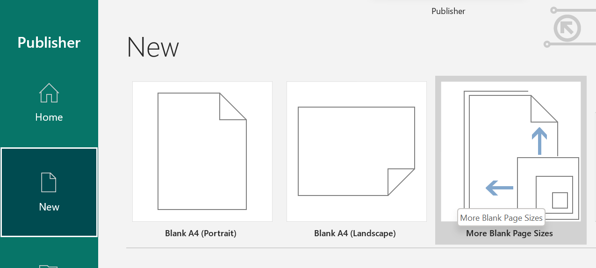
- Look for ‘More Blank Page Sizes’ and double click on that.
- Look for the ‘Booklets’ folder and click on that
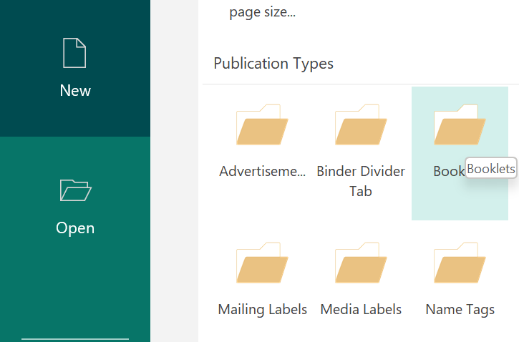
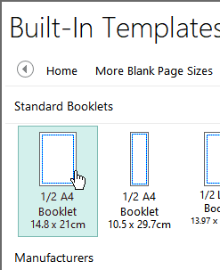
- There are quite a few options here, we can just double click on the first one ‘1/2 A4 Booklet 14.8 x 21cm’

NB: When making these types of publications you might get a message about “automatically inserting pages” to which you can just click the [Yes] button
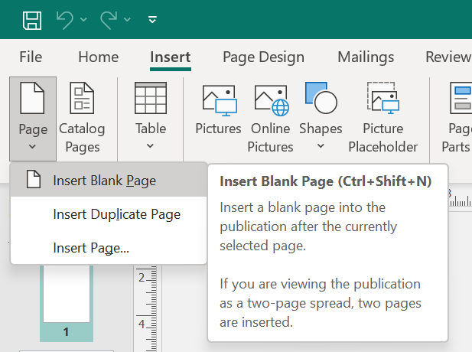
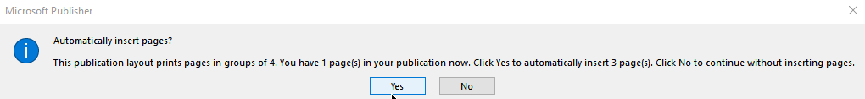
- With our new publication created, we will see three (technically four) pages on the left hand side in our ‘Navigation/ Pages’ area.
- From the ‘Insert’ tab, click the bottom part of the ‘[Page] button (remember from Publisher that some buttons have a top and bottom?) and choose ‘Insert Blank Page’
NB: You will be advised that this will in fact add four pages, click the [Yes] button to confirm
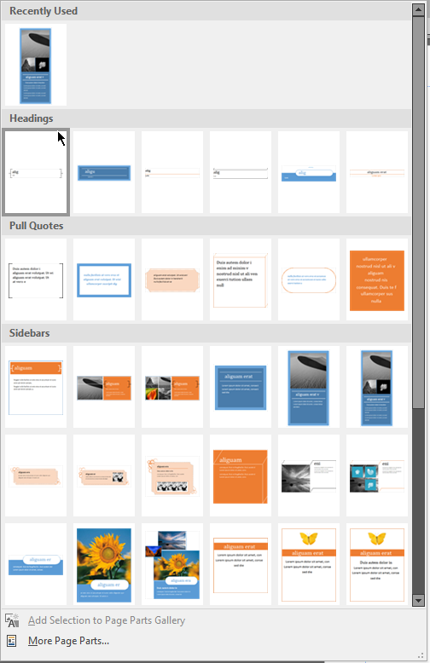
- Now that we have the pages ready for our booklet, it’s time to add some content! Staying in the ‘Insert’ tab, look for the [Page Parts] button and press it.
Here we can see quite a few different pre-made ‘parts’ that we can click on to add to our publication.
- Let’s click on one of the ‘Headings’ to add it.
- I also scrolled down and found one in ‘stories’ that looked good, mouse over and wait for a moment and it will tell you what it’s named. Mine was “Brackets (layout 2)”
Both of these on the same page have kind of interpreted each other, however, publisher being smart like it is moves the text on the tile page part, see on next page.

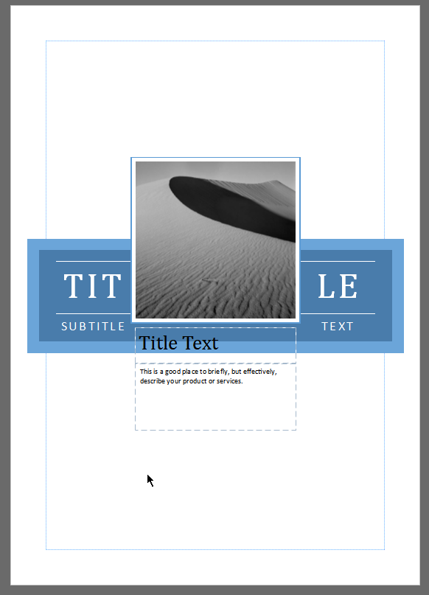
Fortunately we can now grab these elements, move them around and then edit them to make it our own.
I replaced the image, with the picture selected I went to the ‘Insert’ tab, click [Online Pictures] and found one. I was able to click on the existing picture and drag it out (can be a bit fiddly)
I also ‘inserted’ a shape and moved it to behind the other parts of the page.
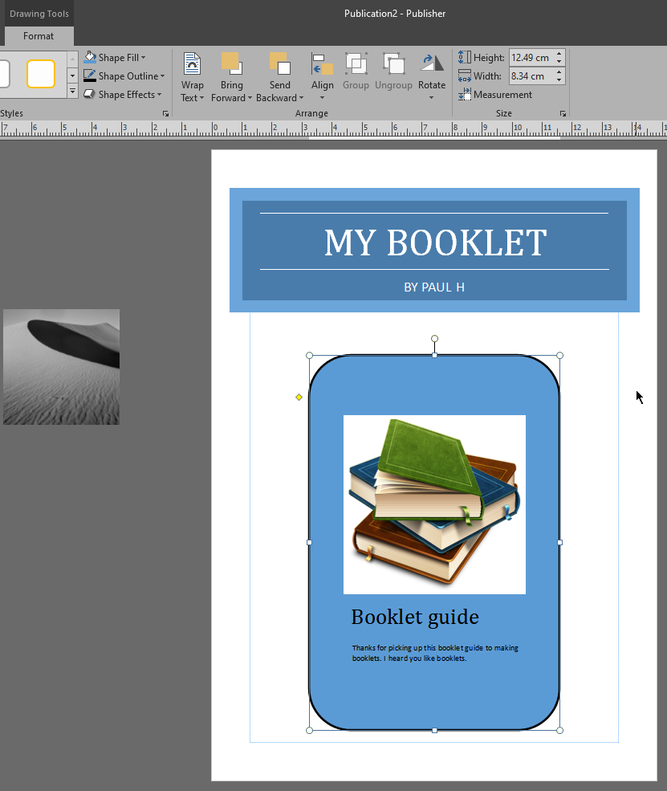

At this point you can do pretty much what ever you like. Perhaps copy some text from the internet, I’m going to grab some text and images from training material I’ve created in the past and see if I can make a good looking booklet.

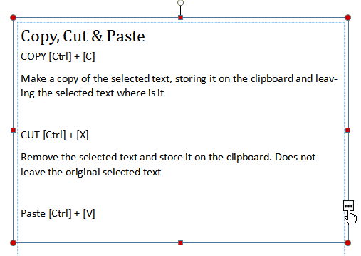
Red dots of doom
If you see red dots around your text boxes, it means that there is too much text and it can’t fit it all in. Luckily there are some options to fix this.
- I usually just adjust the text size, line spacing or the size of the box.
- Click the 3 dots button down the bottom right […] to access the “Spill” controls. Your cursor will change to a cup with letters falling from it. This is a little bit advanced, but if you have another text box (perhaps in another column) you can click on that area to have the text continue over there.
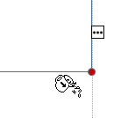

Printing special publications
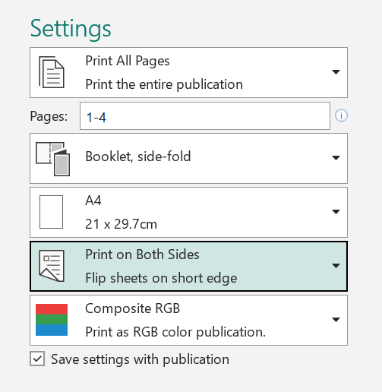
When it comes time to print, there are a few things to check. As this is a booklet, let’s make sure that our booklets look good.
- “Booklet, side fold” is selected
- “Print on Both Sides” is selected with the “Flip sheets on short edge” option. (N.B. long edge for portrait, short edge for landscape)
- Set to colour if you want it
Pro Tip: If you need to print 100, print one first! Fix any mistakes before you commit to a large print job.

