MS PowerPoint - Working with Shapes
Although this document has been created with PowerPoint in mind, the principals and process can be replicated in most other MS Office products. It would be of particular use in Publisher where you can use the techniques described below to add fair to your flyers, booklets and, of course, tri-fold brochures (my personal favourite)

We will be looking at adding shapes, resizing them and adding text inside of them. Finally, we will learn how to move shapes between layers.

A quick note about “Contextual Tabs.” When an object is selected in an Office product, you will often see a new tab apear while said object is still selected. The Tab(s) that appear will be different based on what was selected, if you click on a shape you will get the “Drawing Tool/ Format” tab. If you click on a table, you will get the “Table Tools/ Design & Layout” contextual tab. Cool eh?

- From the ‘Insert’ tab, click the [Shapes] button. Click the desired shape | - Your cursor will change to a small, thin, black cross. Think of this like your paint brush for the shape you are about to draw. I selected a ‘star’ for our shape.

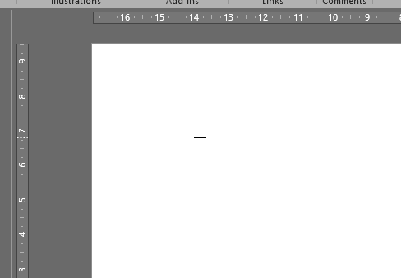
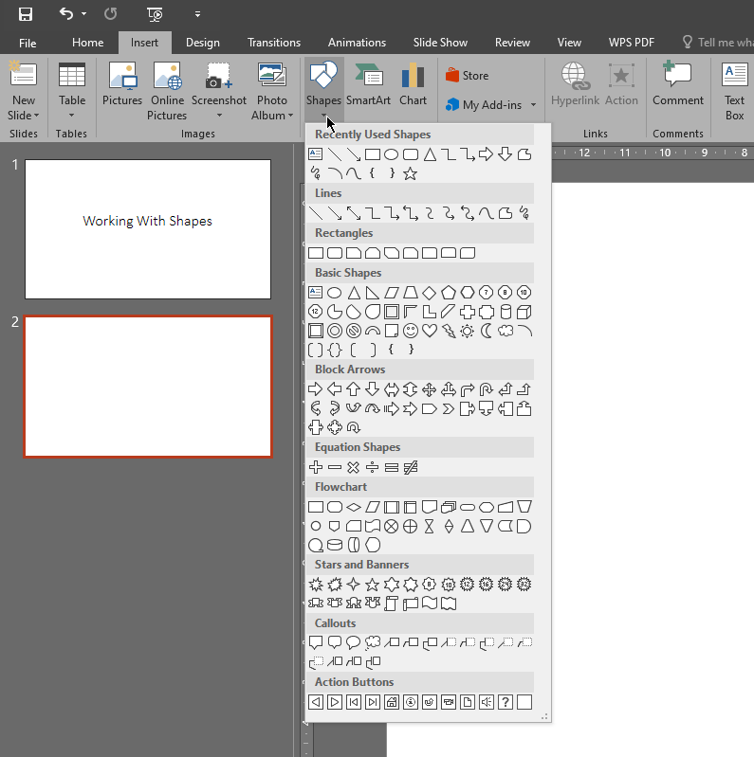

- Left mouse click and drag to make your shape appear, if it does not look right, try holding down the [Shift] key on the keyboard while drawing it. This will lock the ‘ratio’ and force it to maintain it’s shape. Have a play with and without the [Shift] key being held to see what different looks can be achieved.

No [Shift] | With [Shift]
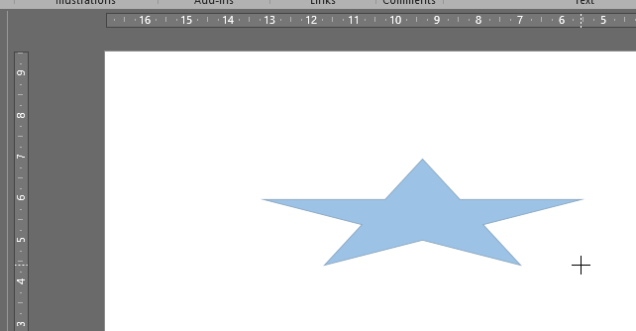 | 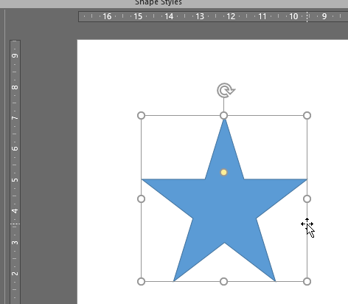

- Let’s draw another shape, from the [Insert] tab, ‘Shapes’ button, ‘Stars and Banners’ group, select one of the ‘banner’ shapes. Left Click and drag to draw it. (Alternatively, you can just Left Click without dragging to place a shape: kind of like a stamp)
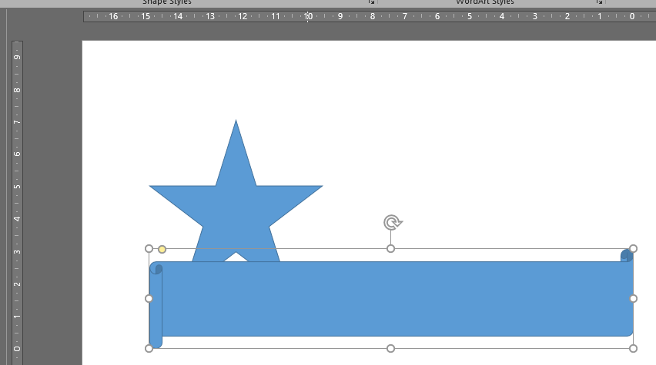

- With the shape selected (can you see the bounding box and handles?) just start typing. Text will appear and can then be edited via the “Drawing Tool/ Format” contextual tab, or, via the home tab like we have done back in MS Word.

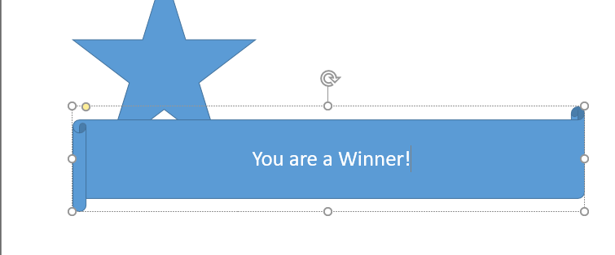

- The style of the shape can be edited from the “Drawing Tool/ Format” contextual tab.

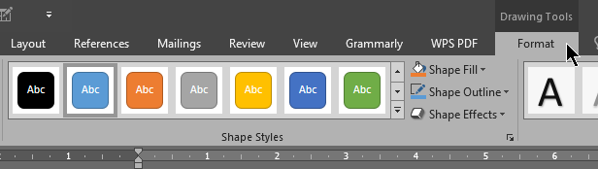

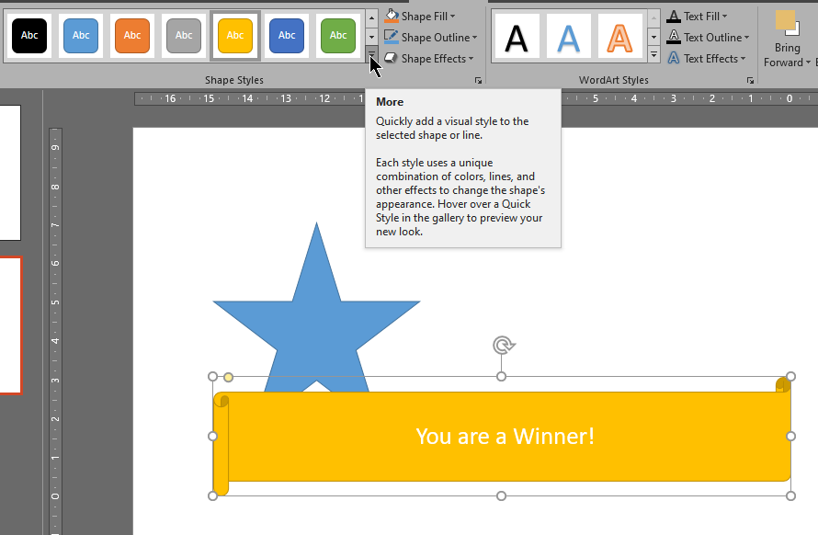

- Finally, you can change the order in which the shapes appear. As each shape is created, it sits one layer above the previous shape. Thing of having multiple pieces of paper cut-out in-front of you and you are able to shuffle them around to have some behind or in-front of the others.

Select (Left Click) on the shape to be re-arranged, in the “Drawing Tool/ Format” contextual tab, click wither on the “Send Backwards/Forwards” button, or on the drop-down arrow for more options.
