Anatomy of a Smart Phone or Tablet
Familiarise yourself with common Android terminology. Some terms that will help you out include the following:
Lock Screen - The screen to which your tablet/phone opens when the display is on but locked.
Home Screen - The screen to which your tablet/phone opens when unlocked.
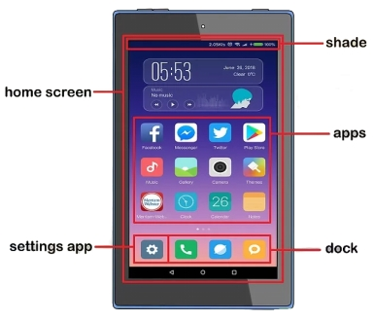
App - A program. Apps are mobile versions of computer programs, websites, and services.
Long-press - An action used to move apps or open a shortcut's menu. Tap and hold something to long-press it. (more on this next page)
Dock - The row of apps at the bottom of the Home Screen. You can customize the Dock to hold apps that you frequently use. It does not move when swiping left or right.
Shade - A notification banner that you can pull down from the top of the screen. The Shade usually has shortcuts to frequently used settings, such as Wi-Fi and Bluetooth.
OK, Google - Android's version of Siri. You can say "OK, Google" to open this voice assistant, at which point you can ask questions (e.g., "Where's the nearest Starbucks?") or give commands (e.g., "Email Sally").

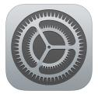
Settings - An app (usually gear-shaped) that contains all of your tablet/ phone's preferences, options, and setup details. If you want to change an aspect of your tablet/ phone, the answer is probably in Settings.
Android
Apple

Controlling your phone or tablet
Your phone and tablet is controlled, for the most part, by manipulating things on the touch-screen. That manipulation happens by using one or two of your fingers. It doesn’t matter which fingers you use and feel free to experiment with other body parts as well.
Here are some of the many ways you can touch the touch-screen:
Touch: The simplest way to manipulate the touch-screen is to touch it. You touch an object, an icon, a control, a menu item, and so on. The touch operation is similar to a mouse click on a computer. It may also be referred to as a tap or press.
Double-tap: Touch the screen twice in the same location. Double-tapping can be used to zoom in on an image or a map, but it can also zoom out. Because of the double-taps dual nature, it is recommended to use the pinch or spread operation instead when you want to zoom.
Long-press: A long-press occurs when you touch a part of the screen and hold down your finger. Depending on what you’re doing, a pop-up menu may appear, or the item you’re long-pressing may get “picked up” so that you can move it around. A long-press might also be referred to as touch and hold down in some documentation.
Swipe: To swipe, you touch your finger on one spot and then drag it to another spot. Swipes can go up, down, left, or right; the touch-screen content moves in the direction you swipe your finger. A swipe can be fast or slow. It’s also called a flick or slide.
Pinch: A pinch involves two fingers, which start separated and then are brought together. The effect is used to zoom out, to reduce the size of an image or see more of a map.
Spread: The opposite of pinch is spread. You start with your fingers together and then spread them. The spread is used to zoom in, enlarge an image or see more detail on a map.
Rotate: A few apps let you rotate an image on the screen by touching it with two fingers and twisting them around a centre point. Think of turning a combination lock on a safe, and you get the rotate operation.


Access the Bluetooth menu
Bluetooth can be used to connect wireless devices, such as headphones, speakers, keyboards and mice. Use the following steps to access the Bluetooth menu.
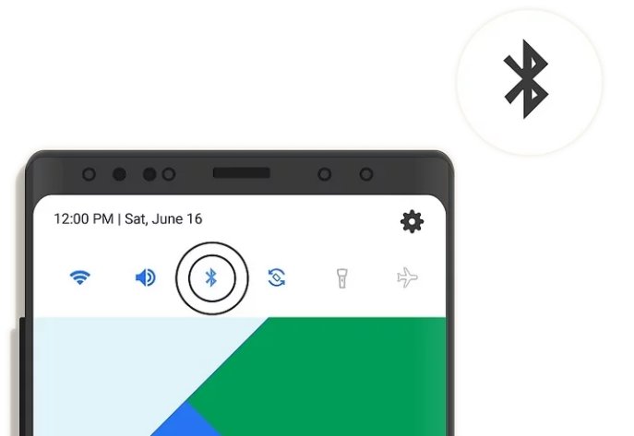
- Swipe down from the top of the screen on Android or the upper-right corner on iPhone.
- Tap the Bluetooth icon to turn Bluetooth on and off. It resembles an angular "B" with a tale.
- Tap and hold the Bluetooth icon to display connected nearby devices.
- Tap a Bluetooth device to pair it.
NB: When pairing a new device you might need to put the device into ‘pairing mode’ refer to the user manuala or try searching YouTube for;
“How to pair a ‘X’ to a ‘Y’”
where ‘’X’ is the brand and type of device (e.g logitech bluetooth keyboard) and ‘Y’ is the device (e.g. Apple iPad), for example
How to pair a logitech bluetooth keyboard to an iPad
