.
Canva - How to Use


A quick introduction to using Cana.com to crate stylish productions. Great for simple documents, effective presentations, flyer, brochure and video related social media posts.
Document Name: Short Module - Canva - How to Use - T2 - 2024 - V0.1.docx
Document Details: Version 0.1 (Q2 - 2024) - April
Document Status: In use

Author: Paul Hobby - hobstar@protonmail.com
Editor: N/A

Legal Information:
This document has been created in accordance and compliance with all of HobStar Computing Solutions’ (to be further referred to as ‘HobStar’) legal obligations. All information is intended as training material and does not necessarily reflect HobStar’s views.

Updates to this document:
This document still requires authorization and checking to be performed in order for it to be considered a legitimate HobStar document. Any version of this document that is listed as a ‘Draft’ is not a finished product and might not reflect the intended finished product.

Usage of this document:
This document is intended to be used by trainers employed by HobStar conjunction with the trainer presenting the information. As a new trial feature, short videos covering in class topics are being created as an additional and optional component of this course. This document may not be reproduced, in part or in whole, without express permission of HobStar.

Notable Version Updates
Version 0.1 - Created - April 2024

Connecting with HobStar Computing Solutions
I’m not a huge fan of social media, I never got why you’d want to share everything you do online. That being said, I do make YouTube videos on doing computer related things, and I have my own version of social media.

I use an app called ‘Discord’ and I do have a presence on Twitter and Facebook, but I’m not very active on there.
Instead of posting many links to everything I do, there’s a QR code you can scan over on the side. And if QR codes aren’t your thing, you can type the link below into your browser (phone, laptop, computer)
www.linktr.ee/hobstar
You can also just search for “HobStar Computing Solutions” in most places (Facebook, YouTube, Twitter, etc.) and you’ll probably find me.
Interesting fact; “Hobstar” is also something to do with glass cups, so you might see some of that too when you’re looking for me. :)
I’d love feedback on your experiences and even any testimonials that you would be willing to provide.
A quick cultural note. Some cultures prefer to refer to their instructors as ‘Sir’ or ‘Teacher’ which is fine with me. You may call me one of those, or simply ‘Paul’, just don’t call me late for dinner. ^{:p}

Section 1 - Getting to Know Canva
Canva is a one stop shop for creatives who want to create engaging and consistently branded content.
To get started you will need a free account. If you wish, you can connect via Google or Facebook, but I prefer to make a new account with my email address and a password I’ve not used anywhere before.
- Navigate to www.canva.com or just search for “Canva” in your preferred browser
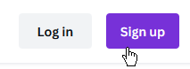
- Click the [Sign up] button if you are new or [Log in] if you a returning (and you know your details)
- Once in, you can select from one of the exiting categories if you know what you want to make, or if you just want to have a look around
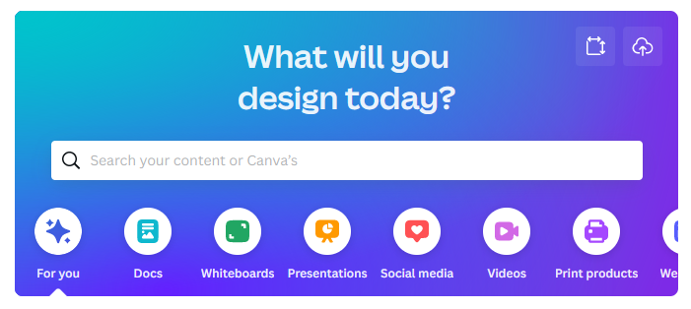
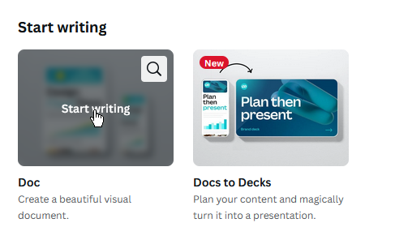
- Let’s start with “Docs” (Documents), so click on that one
- And click on “Start Writing” which appears when you mouse over the image for the first one
NB: a new tab will open with this new document in it

The Interface
The interface for Canva is very simplistic, which is not to say that it is not also feature packed.
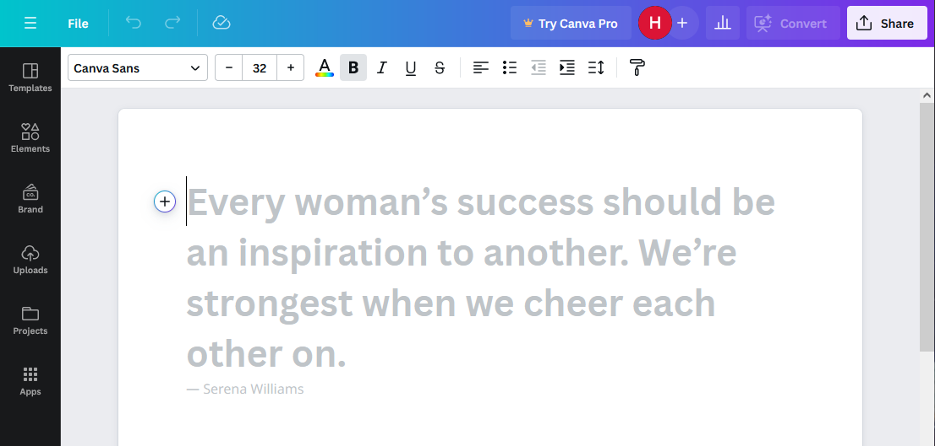
- We have ‘Un-do’ and ‘Re-Do’ options
D
C
A
B
- Font positioning and style options
- Extra things called ‘Elements’ in Canva. These can be clicked and dragged into a Canva project (more on that in a moment)
- Our main working area
To get started
- Click in the main working area (D) and type what would be your heading for this document, e.g. My Resume, Recipes, My Story, etc.
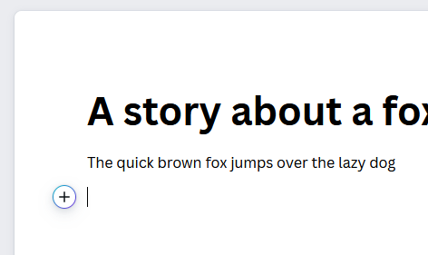
- Press [Enter] and keep typing, you should notice that it’s automatically applied a ‘Heading’ style to the first part and a ‘Normal’ style to the next bit of text
- Note also the (+) button which can be clicked to quickly add an ‘Element’ such as a table, chart, image, style or many more. Give it a click now

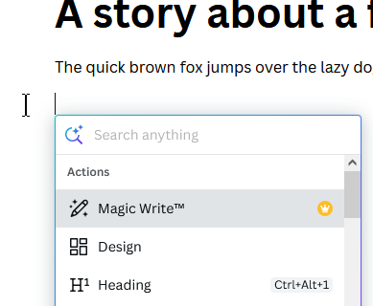
- Here we can see a few of the options. Clicking on ‘Design’ will open a new box in front of your working area. Here you can insert a designer box that can be edited. This does not change the whole document. This is not required, but good to know about.
- Have a look through and try some of the other things that can be added here
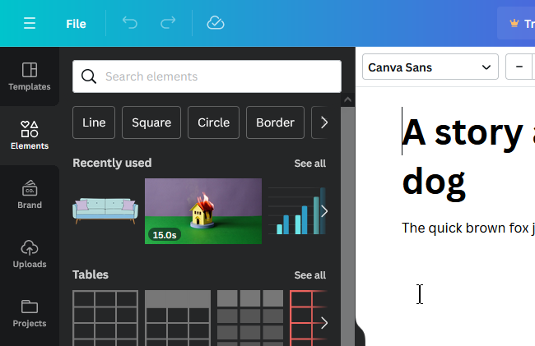
- Next, lest explore the ‘Elements’ (C)
- There is a handy search box here or you can scroll down and use one of the existing elements to add to your project. To do so left click and drag them into your project
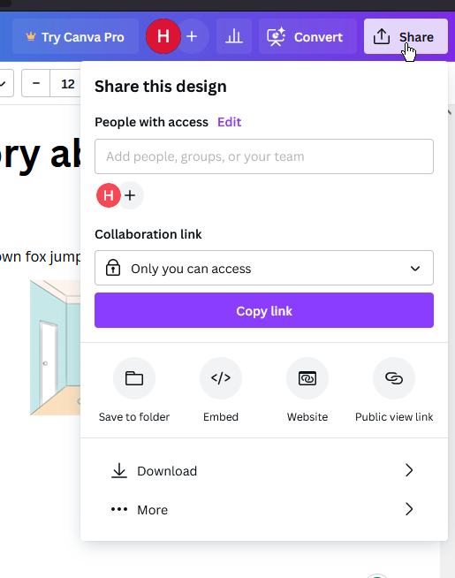
- Finally, you can download your finished project by clicking the [Share] button (top right of screen) and then clicking the [Download] button, you’ll be able to choose from
a) PDF (if you don’t need to edit it later) or
b) DOCX (if you DO want to edit it later)
Now that you have learnt these few simple techniques, the rest of Canva is actually pretty much the same. Start a project, drag elements in, change them, download them.

Section 2 - Working with Canva
This section has been created a video, publicly available on YouTube. To access you can either search YouTube.com for the title below, search for my YouTube channel (HobStar Computing Solutions), scan the QR code below with your smart phone or type in the link below that exactly as it is typed out.
 | Video: “Can I create 5 Canva in just 5 minutes”  Channel: HobStar Computing Solutions
https://youtu.be/yBUnLufnHaw

Section 3 - Shortcuts
Windows | Macintosh
Basic Shortcuts | Basic Shortcuts
Undo: Ctrl + Z  Redo: Ctrl + Y  Save: Ctrl + S  Select all: Ctrl + A  Add text: T  Add rectangle: R  Add line: L  Add circle: C  Add link: Ctrl + K  Add emoji (Canva Docs and comments only): Shift + ;  Add empty page: Ctrl + Enter  Delete empty page: Ctrl + Backspace  Navigate to toolbar Ctrl + F1  Skip to canvas: Ctrl + F2  Canva Assistant shortcut: / or Ctrl + E | Undo: Command-Z  Redo: Command-Y  Save: Command-S  Select all: Command-A  Add text: T  Add rectangle: R  Add line: L  Add circle: C  Add link: Command-K  Add emoji (Canva Docs and comments only): Shift + ;  Add empty page: Command-Return  Delete empty page: Command-Delete  Navigate to toolbar: Command-F1  Skip to canvas: Command-F2  Canva Assistant shortcut: / or Command-E
Element Shortcuts(Win) | Element Shortcuts(Mac)
Delete selected elements: Backspace or Delete  Group elements: Ctrl + G  Ungroup elements: Ctrl + Shift + G  Lock element: Alt + Shift + L  Arrange elements forward: Ctrl + ]  Arrange elements backward: Ctrl + [  Arrange elements to front: Alt + Ctrl + ]  Arrange elements to back: Alt + Ctrl + [  Tidy up elements: Alt + Shift + T  Select next/previous elements: Tab or Shift + Tab | Delete selected elements: Delete  Group elements: Command-G  Ungroup elements: Command-Shift-G  Lock element: Option-Shift-L  Arrange elements forward: Command-]  Arrange elements backward: Command-[  Arrange elements to front: Option-Command-]  Arrange elements to back: Option-Command-[  Tidy up elements: Option-Shift-T  Select next/previous elements: Tab or Shift + Tab
Zooming Shortcuts(Win) | Zooming Shortcuts(Mac)
Zoom in: Ctrl + +  Zoom out: Ctrl + -  Zoom to actual size: Ctrl + 0  Zoom to fit: Alt + Ctrl + 0  Zoom to fill: Shift + Ctrl + 0 | Zoom in: Command-+  Zoom out: Command--  Zoom to actual size: Command-0  Zoom to fit: Option-Command-0  Zoom to fill: Shift-Command-0

