WPS OFFICE
Part 1 - Introduction


This unit has been designed to showcase my personal favourite free alternative to Microsoft (MS) Office’s suite of applications. In particular, alternatives to the three most commonly used applications; Word, Excel and PowerPoint.

There are other free alternatives that will be briefly mentioned but I chose Kingston WPS for it’s comparability with MS Office files and the similarities of the interface. Some of the other free alternatives have better compatibility and some have less, but almost all of them don’t quite match-up to being able to mimic the interface that most people are used to using form MS Office.

This is my personal opinion and others might be able to illustrate ways in which I am incorrect, I welcome the feedback and look forward to re-review alternatives as they make improvements.
Document Name: “WPS OFFICE - v0.1.docx ”
Document Details: Version 0.1 (Q2 2020) - April
Document Status: draft

Author: Paul Hobby - paulh@djerriwarrh.org
Editor: N/A

Legal Information:
This document has been created in accordance and compliance with all of HobStar Computer Services’ (to be further referred to as ‘HobStar’) legal obligations. All information is intended as training material and does not necessarily reflect HobStar’s views.

Updates to this document:
This document still requires authorization and checking to be performed and completed in order for it to be considered a legitimate HobStar document. Any version of this document that is listed as a ‘Draft’ is not a finished product and might not reflect the intended finished product.

Usage of this document:
This document is intended to be presented to students for their use. Any unintended results of using this document can not be held against HobStar

Notable Version Updates
Version 0.1 - Document Created

Introduction
I wrote a blog post a little while back about Kingston WPS, this would be a good place to start. I will be outlining the main features of the article below but it’s a good read and a good place to start. If you would like to have a read, click the link below, or copy and paste it into your favourite web browser or type it in manually to your web browser.
https://hobstar.io/2019/05/27/wps-office-the-free-alternative/
Before I continue any further, a disclaimer is required. Kingston is a Chinese company and there has been un-answered questions raised as to what information is collected. If you are in a government position, it would be better to see one of the other Free Open Source Software (FOSS) solutions out there, some of which we will discuss later.
One of the first things I point out in my article is the price difference between WPS and MS Office.
WPS Free | WPS Office Premium | WPS Office Professional |  | Microsoft Office 365 Home | Microsoft Office 365 Personal | Microsoft Office Student
$0 | $9.99 / 3 Months  $29.99/Year  For 9 devices | $79.99/lifetime (3 years services)  For one PC |  | $13/ month  $129/ year  6 People | $10/ month  $99 / year  1 Person | $199/ one-time  1 Person  Only includes; Word, Excel and PowerPoint
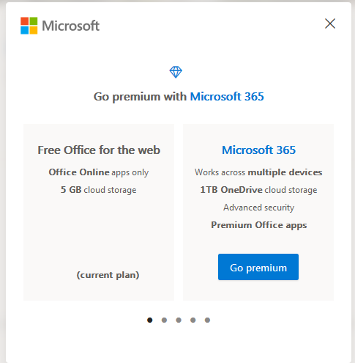
There is also a way to access MS Office for Free id you go to the link below, and sign in with a “Microsoft” account. You will get access to some of the Office suite but this can only be used online.
So you might be asking yourself; “Why not just do this?” and the answer is simple: however, the purpose of this document is to highlight the use of WPS as an installed (offline) alternative.
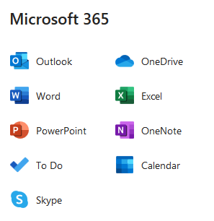
I do like having options though and the more options you have the easier it is to find the one that works for you.
https://www.office.com/
Let’s have a quick look at the the differences between WPS and MS Office;
Microsoft Office 365 (Home and Personal) both have 6 programs; Word, Excel, PowerPoint, Outlook, Access and Publisher) whilst the Student version only has; Word, Excel and PowerPoint.
In comparison, WPS also has 3 main pieces of software to it; Writer (replacement for Word), Presenter (replacement for PowerPoint) and Spreadsheets (replacement for Excel.) This is also where we get the ‘WPS’ from, the first letter of each product. In my humble opinion, these three programs are more than enough to complete almost all of the most common ‘Office type’ functions you will ever need.

Download and Install
You can download it from the link below. There are version for Mac, Windows, Linux and mobile devices. Once downloaded, run the installation file and follow the steps.
https://www.wps.com/
If you need a hand to install please let me know.

The interface (All-in-One Mode)
Before we look at the interface properly, let’s go over one of things that I love about WPS, which is the All-in-One Mode. With this mode enabled you have multiple file types open in the same window. Even when this mode is not enabled, you can have multiple files open of the same type in a single window. The main reason I love this is because I can quickly switch between a Word document and an Excel spreadsheet without have to leave the program.
Below we can see some examples;
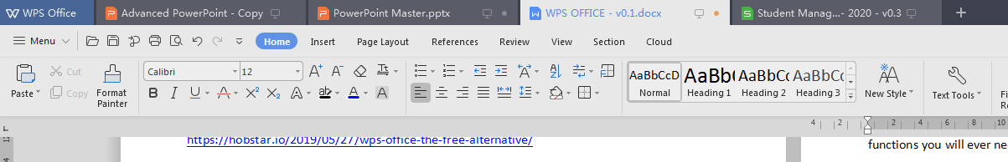
Here, in Fusion Workspace mode, we can see two PowerPoint files, one Word file and one Excel file all open in the one window. You can switch between them by clicking on the tab, just like in a browser.
Another cool trick is being able to grab a tab and disconnect it, this is useful for working on two documents side-by-side.
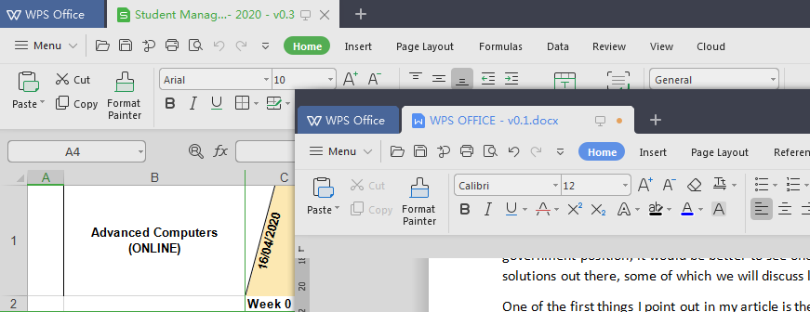

To switch between the Fusion and Non-Fusion modes, you can use the instructions below;
- Click on the [WPS Button] in the top left corner of the program when it’s running
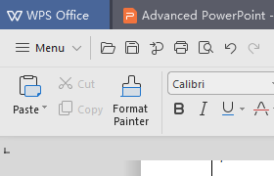
- Click on the [Setting] button in the top right corner of the window that appears
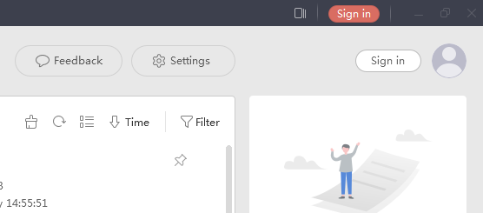
- Click on the second [Settings] button under the first
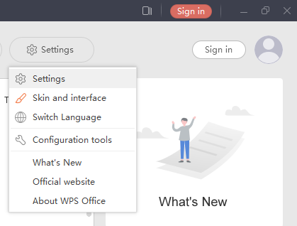
- Down the bottom, click on the [Switch Window Management Mode…] button
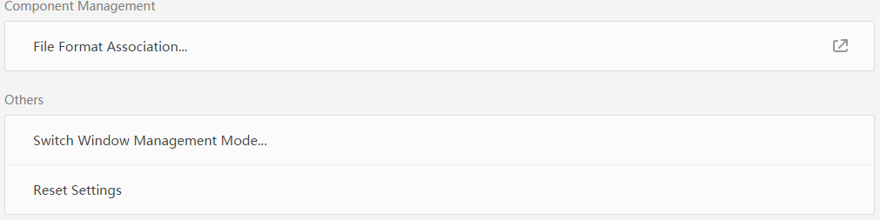

- Select which mode you want based on your preference, or try them both out to see what works best for you
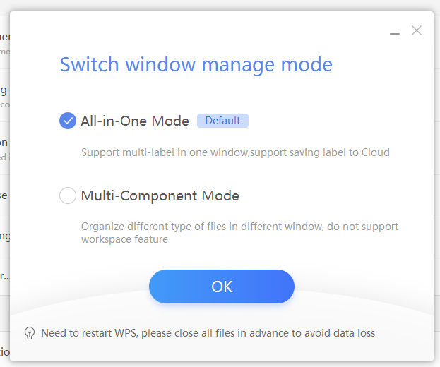

The interface, compared to MS Office
So lets see how the interface stacks up to MS Office 2016. First off WPS Writer and MS Word
WPS Office (Writer);
2
3
4
1
MS Office (Word);
2
1
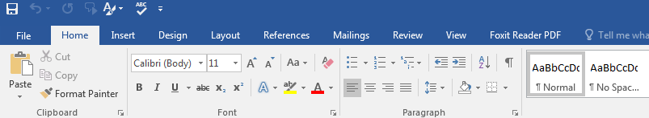
3
4
 | WPS Office | Microsoft Office
- Quick Launch | Not on the top (this allows for the documents as tabs) | Along the top of the window
- Tabs | Under the quick launch icons | Next to the quick launch icons
- Command Groups | Not listed be separated | Separated with titles
- Placement of command buttons | Mostly the same in both | Mostly the same in both
Next, WPS Presenter and MS PowerPoint
WPS Presenter;
2
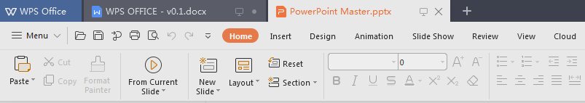
4
3
1
MS PowerPoint;
2
1
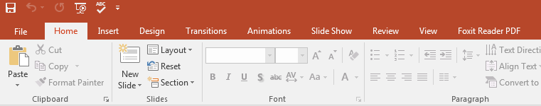
4
3

Finally, WPS Spreadsheets vs MS Excel
WPS Spreadsheets;
2
1
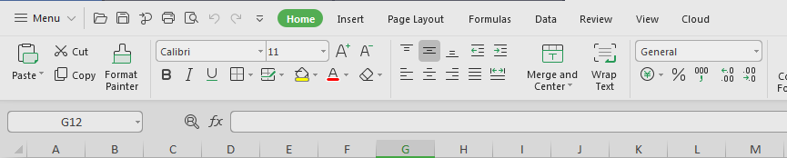
5
4
3
MS Excel;
2
1
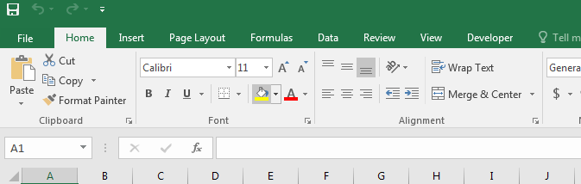
5
4
3
 | WPS Spreadsheet | MS Excel
- Quick Launch | Not on the top (this allows for the documents as tabs) | Along the top of the window
- Tabs | Under the quick launch icons | Next to the quick launch icons
- Command Groups | Not listed be separated | Separated with titles
- Placement of command buttons | Mostly the same in both | Mostly the same in both
- Formula Bar | Same position and same functionality | Same position and same functionality

