.
Canva - How to Use


A quick introduction to using Cana.com to crate stylish productions. Great for simple documents, effective presentations, flyer, brochure and video related social media posts.

Section 1 - Getting to Know Canva
Canva is a one stop shop for creatives who want to create engaging and consistently branded content.
To get started you will need a free account. If you wish, you can connect via Google or Facebook, but I prefer to make a new account with my email address and a password I’ve not used anywhere before.
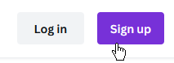
- Navigate to www.canva.com or just search for “Canva” in your preferred browser
- Click the [Sign up] button if you are new or [Log in] if you a returning user, and you know your details. NB: if asked to start trail click [Maybe Later] or look for an [X] button or [Skip] to click
- Once in, you can select from one of the exiting categories if you know what you want to make, or if you just want to have a look around you can search…
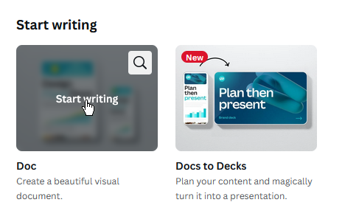
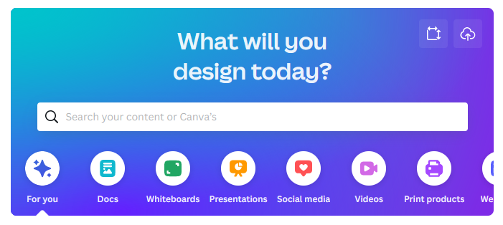
- Let’s start with “Docs” (Documents), so click on that one
- And click on “Start Writing” which appears when you mouse over the image for the first one
NB: A new tab will open with this new document in it

The Interface
The interface for Canva is very simplistic, which is not to say that it is not also feature packed.
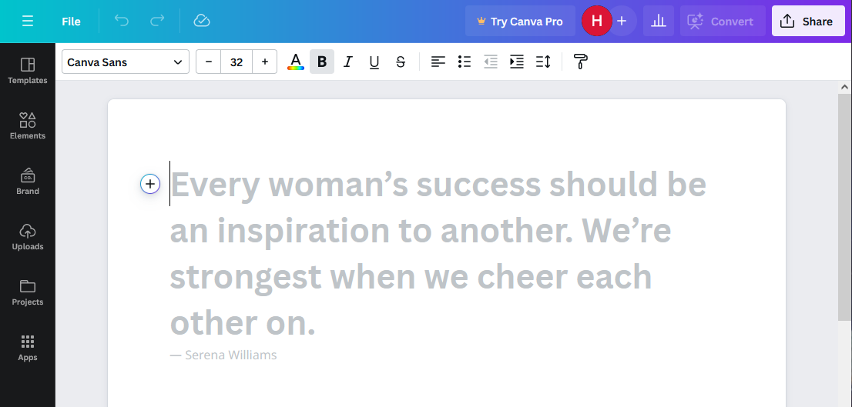
- We have ‘Un-do’ and ‘Re-Do’ options
A
B
C
D
- Font positioning and style options
- Extra things called ‘Elements’ in Canva. These can be clicked and dragged into a Canva project (more on that in a moment)
- Our main working area
To get started
- Click in the main working area (D) and type what would be your heading for this document, e.g. My Resume, Recipes, My Story, etc.
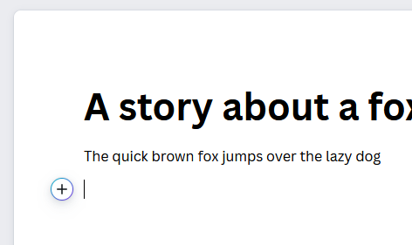
- Press [Enter] and keep typing, you should notice that it’s automatically applied a ‘Heading’ style to the first part and a ‘Normal’ style to the next bit of text
- Note also the (+) button which can be clicked to quickly add an ‘Element’ such as a table, chart, image, style or many more. Give it a click now

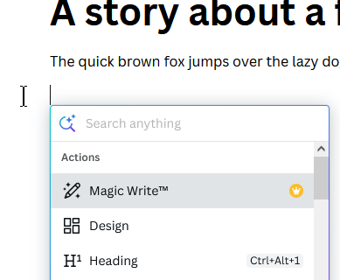
- Here we can see a few of the options. Clicking on ‘Design’ will open a new box in front of your working area. Here you can insert a designer box that can be edited. This does not change the whole document. This is not required, but good to know about. Double click to edit text, select [Save] when done
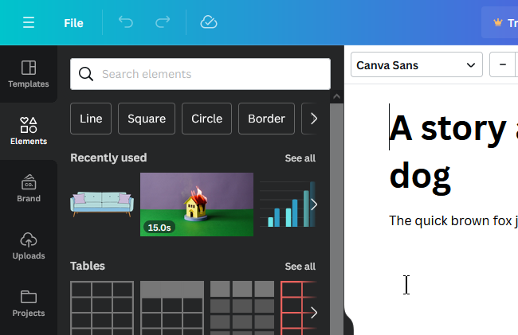
- Have a look through and try some of the other things that can be added here

- Next, lets explore the ‘Elements’ (C)
- There is a handy search box here or you can scroll down and use one of the existing elements to add to your project. To do so left click and drag them into your project
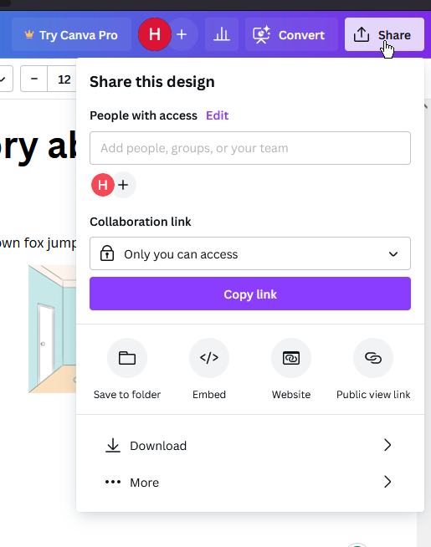
- Finally, you can download your finished project by clicking the [Share] button (top right of screen) and then clicking the [Download] button, you’ll be able to choose from
a) PDF (if you don’t need to edit it later) or
b) DOCX (if you DO want to edit it later)
NB: This file if saved as .docx can now be opened and edited in MS Word
Now that you have learnt these few simple techniques, the rest of Canva is actually pretty much the same. Start a project, drag elements in, change them, download them.

About Canva Pro

Anytime you see the Pro Icon (seen to the right), this feature requires you to have a paid subscription for Canva to use. Fortuently, they offer a generous 30 day free trial that does NOT require a credit card. After that time though the prices for the Pro Plans (should you wish to continue) are as follows;
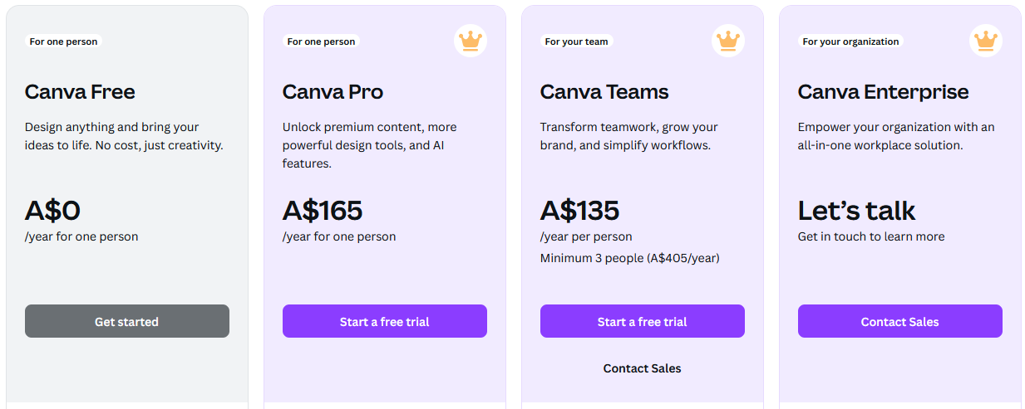
Most of the time I have found that the free version can do everything that I need it to do. The Pro version does have a LOT of very useful features like; many more images and elements to use, in app image background removal, 1000 brand kits to use (you get 1 brand kit in the free version), 1TB cloud storage, Social Content Planner.
You can view all of the difference here; https://www.canva.com/pricing/

Section 2 - Working with Canva
This section has been created as a video, publicly available on YouTube. To access you can either;
- Search YouTube.com for “Hobstar Canva 5 minutes”
- Search for my YouTube channel (HobStar Computing Solutions) and then look for the video
- Scan the QR code below with your smart phone or
- Type in the link below that exactly as it is typed out.
 | Video: “Can I create 5 Canva in just 5 minutes”  Channel: HobStar Computing Solutions
https://youtu.be/yBUnLufnHaw

