Canva AI
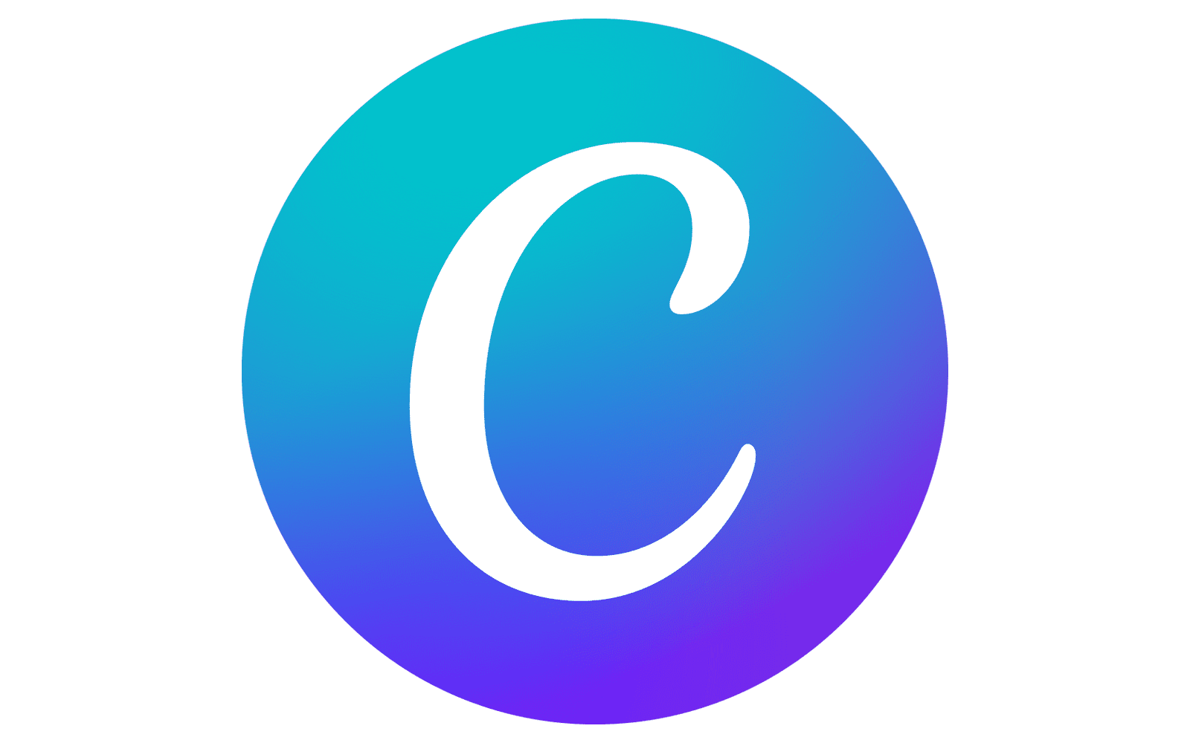

Document Name: Student Book - Canva AI - T2 - 2025 - v0.2. docx
Document Details: Version 0.1 (Q2 - 2025) - May
Document Status: in use

Author: Paul Hobby - hobstar@pm.me
Editor: N/A

Legal Information:
This document has been created in accordance and compliance with all of HobStar Computing Solutions’ (to be further referred to as ‘HobStar’) legal obligations. All information is intended as training material and does not necessarily reflect HobStar’s views.

Updates to this document:
This document still requires authorization and checking to be performed for it to be considered a legitimate HobStar document. Any version of this document that is listed as a ‘Draft’ is not a finished product and might not reflect the intended finished product.

Usage of this document:
This document is intended to be used by trainers employed by HobStar in conjunction with the trainer presenting the information. As a new trial feature, short videos covering in-class topics are being created as an additional and optional component of this course. This document may not be reproduced, in part or in whole, without the express permission of HobStar.

Notable Version Updates
Version 0.1 - Created - Feb 2025
Version 0.1b - Condensed, improved line spacing

Table of Content
Table of Content 4
Overview Table: Canva AI Features, Free vs Pro 5
3 ways to make a presentation 8

AI With Canva

Overview Table: Canva AI Features, Free vs Pro
Feature | Free Tier Usage | Pro Tier Usage | Pro Required?
Magic Write | 50 total uses | 500 uses/month | No (limits)
Magic Media (Text to Image) | 50 total uses | 500 uses/month | No (limits)
Magic Media (Text to Video) | 5 total uses | 50 uses/month | No (limits)
Magic Edit | 100 uses/day | 100 uses/day | No
Magic Design | 10 total uses | 100+ uses/day | No (limits)
Magic Morph | Not available | Unlimited | Yes
Magic Grab | Not available | Unlimited | Yes
Magic Eraser | Not available | Unlimited | Yes
Magic Expand | Not available | Unlimited | Yes
Magic Animate | Not available | Unlimited | Yes
Magic Resize | Not available | Unlimited | Yes
Background Remover | Not available | Unlimited | Yes
Translate | 50 total pages | 500 pages/month | No (limits)
AI Avatars | Limited (exact quota varies) | Full access | Likely*
Brand Voice (Magic Write) | Limited | Full access | Yes
Beat Sync (Video) | Not available | Unlimited | Yes
Enhance Voice (Audio/Video) | Not available | Unlimited | Yes
Code for Me (AI Widget) | Limited free credits | Full access | Yes
*AI Avatars and some features may be in beta or have changing quotas—always check Canva’s official documentation for the latest.
Canva offers a suite of AI-powered features designed to speed up and enhance your creative process. Below is a comprehensive list of major Canva AI features, what they do, and how to use each one.

1. Magic Write (AI Text Generator) - 50 total uses for free
Use:
Instantly generates written content for social posts, blogs, presentations, business plans, and more.
Can rewrite, summarize, or adjust the tone of existing text
Instructions:
- Open or create a Canva Doc, presentation, or any design.
- Click the [Magic Write] button (tool bar)
- Enter a detailed prompt describing the content you want (e.g., “10 Instagram captions for summer travel”).
- Press Enter to generate text.
- Edit or refine as needed, then add the content to your design

- Magic Media (Text to Image, Video, and Graphics) - 50 total uses for free
Use:
Generates images, videos, or graphics from text prompts.
Useful for creating unique visuals, product mockups, or brainstorming creative ideas
Instructions:
Go to the Apps panel or search for "Magic Media."
Choose to generate an image, video, or graphic.
Enter a detailed description of what you want.
Select a style (e.g., Photo, Watercolor, Anime) and aspect ratio.
Click "Generate Image" or "Generate Video."
Select your favorite result and add it to your design

3. Magic Edit - 100 uses/ day for free
Use:
Edits specific parts of images by replacing or modifying objects using AI.
Ideal for swapping objects, removing distractions, or transforming photos
Instructions:
Add a photo to your design.
Click on the photo, then select "Edit Photo."
Choose "Magic Edit."
Adjust the brush size and highlight the area to change.
Describe what you want to appear in that area (e.g., “replace with a bouquet of flowers”).
Click "Generate" and choose your preferred option

4. Magic Design - 10 total uses for free
Use:
Generates complete design templates, presentations, or videos from a simple prompt.
Great for quickly starting projects with personalized layouts
Instructions:
Click the “Design” tab or use the AI search bar on the homepage.
Select "Design for me."
Enter a specific prompt (e.g., “presentation on digital marketing trends”).
Browse suggested templates and select one to customize.
Edit as needed and download or share your design

5. Translate - 50 pages total for free
Use:
Translates text in your designs to multiple languages using AI
Instructions:
Select the text box in your design.
Click "Apps" and find "Translate."
Choose the target language.
The AI translates the text; review and edit for accuracy.

3 ways to make a presentation
Option 1. Start with a Ready-Made Presentation Template
What:
Choose from thousands of professionally designed presentation templates tailored for different themes and purposes (business, education, events, etc.).
How to do it:
- Log in to Canva and click Create a design > Presentation.
- Browse or search for a template by keyword (e.g., “science,” “business,” “Halloween”).
- Click a template to preview, then click the + or Use this template to add all slides to your project.
- Customize text, images, colors, and fonts to fit your content.
- Add or remove slides as needed.
Use case: Quick, polished presentations with minimal design effort
Option 2. Build a Presentation from Scratch Using Blank Slides
What:
Create a fully custom presentation by starting with a blank canvas and adding your own elements, text, images, and layouts.
How to do it:
- From Canva’s homepage, click Create a design > Presentation > choose Blank presentation.
- Add new blank slides via the + Add page button.
- Use Canva’s side panel to add text boxes, shapes, photos, icons, and more.
- Customize fonts, colors, and layouts freely.
- Arrange slides in your preferred order.
- Use case: Maximum creative control for unique or highly customized presentations

Option 3. Use Canva’s Magic Design (AI-Powered Presentation Generator)
What:
Let Canva’s AI generate an entire presentation based on a simple text prompt describing your topic.
How to do it:
- On the Canva homepage, find and select Magic Design or use the AI-powered design prompt feature.
- Enter a detailed description of your presentation topic (e.g., “marketing strategy presentation”).
- Canva generates slide layouts and content suggestions automatically.
- Review, customize text and visuals, and finalize your presentation.
- Use case: Fast creation of a structured presentation when you want AI assistance to generate ideas and layouts (Pro feature with usage limits)

Method | Best For | How to Start | Customization Level
Template-Based Presentation | Fast, professional results | Create design > Presentation > Pick template | Moderate (edit existing)
Blank Canvas Presentation | Full creative freedom | Create design > Presentation > Blank | High (build from scratch)
Magic Design (AI-generated) | Quick AI-assisted creation | Use Magic Design, enter prompt | Moderate (edit AI output)

These methods cover the main ways to create presentations in Canva, from quick template use to fully custom designs or AI-generated slide decks.

